Estimating the potential impact of an Africa Automotive Pact on the East African Community and Ethiopia

A Report for the African Association of Automotive Manufacturers (AAAM)

Submitted to:
Dave Coffey
Chief Executive Officer, African Association of Automotive Manufacturers

Compiled by:
The Sub-Saharan African Automotive Pact Task Team
Justin Barnes, B&M Analysts
Alec Erwin, Ubu Investment Holdings
3rd July 2020

Contents

Contents 2
Foreword 3
Acronym List 4
Executive summary 5
1. Introduction 7
2. Mapping the EAC and Ethiopia vehicle market potential 9
2.1. EAC and Ethiopia vehicle market consumption to 2035 based on status quo 10
2.2. Adjusted EAC and Ethiopia vehicle market consumption to 2035 (based on the substitution of used vehicle imports) 11
2.3. Establishment of a market-related production equivalency in the EAC and Ethiopia (GVA, employment etc.) 12
2.4. EAC and Ethiopia market extension: including Egypt, Saudi Arabia, Iran, and Pakistan 13
3. Defining hub and spoke opportunities for EAC and Ethiopia 14
3.1. Potential hub opportunities 14
3.1.1. Kenya 15
3.1.2. Ethiopia 18
3.1.3. Tanzania 23
3.2. Broader EAC opportunities 27
3.2.1. Direct economic benefits 27
3.2.2. Potential component benefits 27
3.2.3. Motorcycle capabilities 28
3.2.4. Agriculture, mining, and construction equipment capabilities 30
4. EAC-Ethiopia trade and market dynamics 32
4.1. EAC trade and market dynamics 32
4.1.1. Kenya 33
4.1.2. Tanzania 34
4.1.3. Rwanda 34
4.2. Ethiopia trade and market dynamics 34
5. Summary of findings and recommendations 36
6. References 38
Annexure 1: African Automotive Pact Model Parameters 39

Foreword
This study has been commissioned by the African Association of Automotive Manufacturers (AAAM). It reviews the potential economic impact of an African Auto Pact on the East African Community (EAC) and Ethiopia. It does so by modelling the potential impacts of the Pact on EAC members and Ethiopia, and by interrogating its potential framework and modalities.
As the service providers commissioned to complete the African Auto Pact project; Ubu Holdings and B and M Analysts SA (Pty) Ltd (‘B&M Analysts’) are responsible for the content presented in this report. In this regard, special acknowledgement needs to be given to Mr Mbongeni Ndlovu, the head of B&M Analysts’ research unit, for his management of the project deliverable; and to Mr Christopher Grant, who was responsible for most of the Auto Pact modelling. While a team worked on the project, the individual authors acknowledge that all omissions or errors in the report are theirs alone.
Whilst every care has been taken to ensure the accuracy and integrity of the information and analysis presented in this report, the African Auto Pact Task Team take no responsibility whatsoever for decisions derived from its content.

Acronym List
AAAM | African Association of Automotive Manufacturers
CAGR | Compound Annual Growth Rate
CBU | Completely Built Up
CET | Common External Tariff
CKD | Completely Knocked Down
DKD | Disassembly Knock Down
EAC | East African Community
EPA | Economic Partnership Agreement
FTA | Free Trade Agreement
GDP | Gross Domestic Product
GVA | Gross Value Add
LCV | Light Commercial Vehicles
M&HCV | Medium and Heavy Commercial Vehicles
OICA | Organisation Internationale des Constructeurs d’Automobiles
SEZ | Special Economic Zone
SKD | Semi-Knocked Down
SME | Small and Medium Enterprise
SSA | Sub-Saharan Africa
TRIMs | Trade-Related Investment Measures
WTO | World Trade Organisation

Executive summary
- Despite the EAC and Ethiopia having an aggregate population of around 300 million, the region only sold about 30,000 new vehicles in 2018 and only produced around 12,000 vehicles. Pre-owned vehicle imports and a plethora of small, disconnected domestic markets ensure that there is limited scope for the creation of a sustainable, large scale automotive industry in the region.
- The African Auto Pact demand model developed by B&M Analysts shows a relatively non-dynamic automotive market in the region to 2035. If pre-owned vehicles continue to be imported in volume, the EAC and Ethiopia are projected to only sell approximately 85,614 new vehicles in 2035.
- The reduction of pre-owned vehicle imports will have a significant impact on new vehicle demand in the EAC and Ethiopia, with new vehicle demand potentially reaching 445,176 units in 2035 (assuming the full elimination of pre-owned vehicle imports). The most attractive markets in the EAC and Ethiopia are:
  - Kenya, with demand of 80,340 units in 2020, increasing to 174,020 units in 2035.
  - Tanzania, where demand increases from 32,301 units in 2020 to 78,058 units in 2035; and
  - Ethiopia, with demand of 30,380 units in 2020, increasing to 112,814 units in 2035
- Based on the 2016 economic profile of the South African automotive industry, and new vehicle demand in the region of 445,176 units in 2035, the following socio-economic benefits can be projected for the development of a CKD-based regional automotive industry that produces the same number of vehicles sold in the market: additional GVA of $1.78 billion, and the creation of 46,482 jobs.
- If the EAC and Ethiopia were to capture 10% of vehicle sales in other potential markets of Egypt, Saudi Arabia, Iran, and Pakistan by 2035, this would represent a further 200,000 units of additional demand which could potentially add an additional 20,600 jobs and $800 million in GVA to the region.
- The Auto Pact structure in the EAC and Ethiopia would include the establishment of three to four CKD plants producing between 80,000 and 100,000 units per model concentrated in the hub economies of Kenya, Ethiopia and, possibly, Tanzania. Then hub economies can, in turn, trade with one another, trade with other SSA hubs such as South Africa and Nigeria, and also export these models. Trade in various complementary models will ensure that the EAC and Ethiopia have sufficient model variability to meet the demand requirements.
  - The spoke economies of Rwanda, Uganda, South Sudan, and Burundi will benefit from the Auto Pact by developing automotive components and producing complementary vehicles such as motorcycles and off-highway agricultural, mining and construction equipment.
- These spoke (component) economies will benefit from supplying the hubs, as follows:
  - Of the total GVA benefits, we estimate that the automotive industry could contribute a potential of $406 million in GVA in the spoke economies by 2035.
  - Based on this GVA, all of which would represent foreign exchange savings and a positive contribution to the region’s trade balance, the spoke economies could employ 9,227 people in component manufacturing operations (for the vehicle assemblers), with a further 1,845 employed in aftermarket related component activities. Therefore, the Pact would generate an estimate of 11,072 jobs in total.
- Based on an analysis of the trade data, the spoke economies have very limited existing component capabilities but there is potential for development of parts and accessories, and tyres in Uganda, Burundi, and Rwanda.
- As a region, the EAC and Ethiopia has maintained a large trade deficit on motorcycles. The largest trade deficits are from Kenya, Ethiopia, and Uganda. Uganda is the only country with significant exports of motorcycles in 2018. Uganda exported approximately 21,000 motorcycles in 2018.
- The large size of the agriculture, mining, and construction equipment market in Ethiopia provides an opportunity for introduction of an agriculture, mining, and construction equipment within the African Auto Pact arrangement.
- The key policy and implementation considerations for establishing a regional trade Pact between the EAC and Ethiopia include:
  - Accepting the economic logic of working with a larger region in the form of the EAC and Ethiopia, rather than concentrating solely on the EAC.
  - Ensuring that the Kenyan Automotive Policy includes a reduction in pre-owned imports or a more expedited process to reduce the age of vehicle imports.
  - Developing a harmonised duty and incentive structure between EAC and Ethiopia, by including automotive products in the higher band of the revised EAC CET (to 30% or 35%).
  - Attracting component and complementary manufacturing investments into spoke economies, to ensure the establishment of a regional production dynamic of benefit to all participating economies.

Introduction
The East African Community (EAC) political and economic union of consists of six countries in the African Great Lakes region in eastern Africa. The EAC consists of Burundi, Kenya, Rwanda, Tanzania, Uganda, and South Sudan. The EAC is one of the most sophisticated regional intergovernmental partnership in Africa as the region has established a Free Trade Area (FTA), Customs Union (CU), and Single Market for the trade of goods. Whilst the degree of economic integration of the EAC might suggest that it should be analysed as such, there are a number of factors that make analysis along with Ethiopia a more meaningful economic exercise.
Ethiopia, the second largest country in Africa by population size, neighbours the EAC. Ethiopia is in the process of joining the World Trade Organisation (WTO) and plans to become a full COMESA (Common Market for Eastern and Southern Africa) FTA member by 2021; thereby indicating its willingness to participate in African regional value chains. If the EAC and Ethiopia would combine, the region of EAC and Ethiopia would be large and well located for trade with other regions. This will offer the advantages of greater economies of scale for the region. However, at present, manufacturing is still a relatively small share of economic activity in the region. Without widespread industrialisation, the region is unlikely to experience employment growth, improved living standards, and increasing technological innovation.
Despite the EAC and Ethiopia having an aggregate population size of around 300 million, the region only sold about 30,000 new vehicles in 2018 and only produced approximately 12,000 vehicles. Pre-owned vehicle imports and a plethora of small, disconnected domestic markets ensure that there is limited scope for the creation of a sustainable, large scale automotive industry in the region. This significantly limits the potential for large scale automotive assembly and component manufacturing, and consequent industrialisation, which is one of the region’s primary development requirements. A separate focus on the EAC and Ethiopia, with no economic integration mechanisms, would further limit the opportunities for auto production.
Looking forward 15 years, the region will have an additional 150 million inhabitants and is expected to have some of the most densely populated cities in Africa. This means that there is significant potential to develop a regional automotive industry. This potential will, however, only be realised if a regional automotive market and associated production dynamic is created. The region is also adjacent to a number of other significant and relatively large developing economies and this strategic location is factored into the analysis.
The Sub-Saharan African Automotive Pact (‘SSA Auto Pact’) project completed for the African Association of Automotive Manufacturers (AAAM) in July 2019, presented the evidence for a sub-continental automotive production structure in SSA, built around three to four hub economies (South Africa, Nigeria, Kenya and potentially Ghana) and an associated spread of value adding activities to neighbouring economies that could participate in the value chain based on their comparative locational advantages. The intention of the Pact is to catalyse the development of a large scale regional automotive industry. The conceptual framework to the model is presented in Figure 1. As revealed, the emergence of the hub economies within a regional market and production dynamic is central to the SSA Auto Pact concept. For example, Kenya or Ethiopia have the potential to be major assemblers of vehicles, with components for vehicles assembled by other EAC economies.
Figure 1: Hub and spoke model for SSA Automotive Pact development
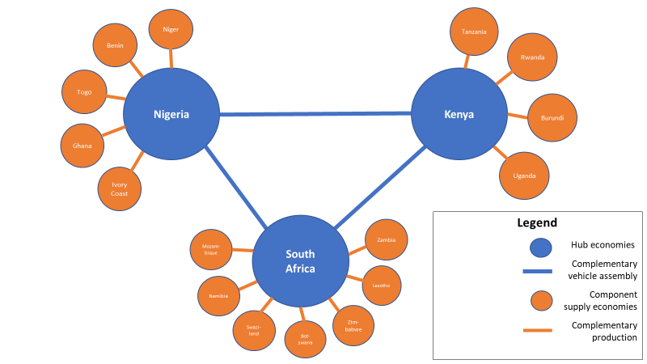
Key to the realisation of the Pact concept in the EAC and Ethiopia, is unlocking automotive value addition and substantially growing CBU and associated automotive component production in the region. Initially, activity would be concentrated in the hub economies based on the establishment of CKD-based vehicle assembly capacity. After this development, spoke economies would be incorporated as automotive value chains are established, and Tier 1 and Tier 2 automotive component manufacturing activity is established in alignment with identified sources of comparative advantage.
This report focuses on the potential (and associated complexities) of establishing a CKD-based automotive manufacturing system based on the hub and spoke concept presented in Figure 1 in EAC and Ethiopia. The report comprises five sections. Following this introduction, Section 2 unpacks the economic rationale for a regional Pact in EAC and Ethiopia. The section projects new vehicle growth opportunities based on a set of realisable scenarios and explores the development of an associated production equivalency. Section 3 presents the country-specific opportunities available to the Pact’s potential hub and spoke economies. In Section 4, the report shifts to an analysis of the Auto Pact within the EAC’s complex regional trade agreements.

Mapping the EAC and Ethiopia vehicle market potential
As part of the African Auto Pact project, a model was developed to estimate the potential for a regional automotive industry in Africa. This project will focus on the potential in the EAC and Ethiopia. The methodology followed is depicted in Table 1.
Table 1: The EAC and Ethiopia vehicle demand model methodology
Indicator | Methodology
Base vehicle demand data | - Base vehicle demand data was calculated using new vehicle sales data and pre-owned vehicle import data for the past 10-year period (2009-2018). This data is depicted in Table 2 and Table 3.
Vehicle demand growth | - CAGR growth rates of the population in economies earning more than $10,000 per annum was calculated. Each economy’s base vehicle demand profile was linked to the base population earning above $10,000. Absolute new and pre-owned imported vehicle demand growth was then projected on the basis of the change in this population group to 2035.
Adjusted new vehicle demand data | - Adjusted new vehicle demand is the demand we estimate for the EAC economies’ and Ethiopia if pre-owned vehicle imports are banned, thereby forcing the consumption of new vehicles only.  - We estimate that there will be a 20% absolute loss in vehicle demand as some consumers, who would have been able to afford a pre-owned vehicle import are no longer able to purchase a new vehicle. The balance was modelled to purchase new vehicles.
Production Equivalency Model (PEM) | - The adjusted new vehicle demand data for 2019 through to 2035, was then imputed into a Production Equivalency Model (PEM), which estimates the impact of new vehicles being manufactured in Africa, rather than being imported from outside of the sub-continent.  - The PEM considers aggregate production values, Gross Value Addition (GVA), employment (vehicle and component manufacturing) and investment opportunities associated with the equivalent production of new models.  - The model is based on the production of a vehicle worth $10,000 per unit. Production values are calculated by multiplying the adjusted new vehicle demand by this unit price.  - GVA is calculated at 40% of production value, as per the South African standard.  - However, GVA is split amongst the countries, with this based on the distribution on vehicle sales in 2018.  - Based on the distribution of 2018 vehicle sales, 3 Hub economies were identified: Kenya, Ethiopia, and Tanzania. These make up 76% of vehicle sales in the EAC and Ethiopia in 2018.  - Therefore, 76% of GVA is allocated to the 3 hub economies and the rest allocated to the spoke economies.  - Employment is calculated by dividing GVA by GVA per employee. The South African standard for GVA per employee was applied.  - Employment was then split between vehicle and component manufacturing at a ratio of 1:3 (again the South African standard).  - Lastly, the African investment opportunity was calculated by multiplying annual new vehicle sales by $10,000. This is the investment level we have calculated for an average eight-year production run.  - This model was then applied to each country in the EAC and Ethiopia.

EAC and Ethiopia vehicle market consumption to 2035 based on status quo
The African Automotive Pact model shows a relatively non-dynamic automotive market in the region to 2035. If pre-owned vehicles continue to be imported in volume by the growing adult population that earns more than $10,000 per annum, the EAC and Ethiopia are projected to only sell approximately 85,614 new vehicles in 2035. Ethiopia and Kenya are expected to continue dominating new vehicle demand in the region at 35,519 and 25,452 units, respectively. This would represent regional growth of around 55,000 units on 2018 levels, when only 29,961 new vehicles were sold. This forecast is presented in Table 2 below.
Table 2: Estimated new vehicle sales to 2035, based on the existing market consumption profile
 | 2018 | 2020 | 2023 | 2026 | 2029 | 2032 | 2035
Burundi | 900 | 935 | 990 | 1 049 | 1 110 | 1 176 | 1 245
Kenya | 10 600 | 11 751 | 13 715 | 16 008 | 18 684 | 21 807 | 25 452
Rwanda | 522 | 592 | 714 | 862 | 1 041 | 1 257 | 1 517
South Sudan | 1 409 | 1 253 | 1 050 | 880 | 738 | 619 | 519
Tanzania | 4 500 | 5 062 | 6 039 | 7 204 | 8 595 | 10 253 | 12 232
Uganda | 4 000 | 4 408 | 5 099 | 5 898 | 6 823 | 7 892 | 9 129
Ethiopia | 8 030 | 9 565 | 12 435 | 16 166 | 21 016 | 27 322 | 35 519
EAC | 21 931 | 24 000 | 27 607 | 31 901 | 36 990 | 43 004 | 50 095
EAC plus Ethiopia | 29 961 | 33 565 | 40 042 | 48 067 | 58 007 | 70 326 | 85 614
The continued importing of pre-owned vehicles in large quantities is the major reason for the limited new vehicle sales projected in Table 2 above. Imports of pre-owned vehicles are projected to substantially increase by 2035, as presented in Table 3 below. Kenya is, for example, estimated to import around 185,709 pre-owned vehicles by 2035, while Ethiopia is projected to import 96,618 units. Other substantial projected importers are Tanzania (82,283 units) and Uganda (77,188 units). In aggregate, the region is projected to import nearly 450,000 pre-owned vehicles by 2035, up from 170,055 units in 2018. This represents just under 16,500 vehicles of annual growth to 2035 which is five times the level projected for new vehicles.
Table 3: Estimated pre-owned vehicle imports to 2035, based on the existing consumption profile
 | 2018 | 2020 | 2023 | 2026 | 2029 | 2032 | 2035
Burundi | 1 529 | 1 589 | 1 683 | 1 782 | 1 887 | 1 998 | 2 116
Kenya | 77 341 | 85 737 | 100 069 | 116 797 | 136 322 | 159 111 | 185 709
Rwanda | 1 420 | 1 610 | 1 943 | 2 346 | 2 832 | 3 418 | 4 127
South Sudan | 3 832 | 3 407 | 2 857 | 2 395 | 2 008 | 1 684 | 1 412
Tanzania | 30 270 | 34 049 | 40 621 | 48 461 | 57 813 | 68 971 | 82 283
Uganda | 33 820 | 37 268 | 43 110 | 49 868 | 57 685 | 66 727 | 77 188
Ethiopia | 21 843 | 26 019 | 33 825 | 43 974 | 57 167 | 74 320 | 96 618
EAC | 148 212 | 163 659 | 190 282 | 221 648 | 258 547 | 301 910 | 352 834
EAC plus Ethiopia | 170 055 | 189 678 | 224 107 | 265 622 | 315 714 | 376 229 | 449 452
The findings presented in Table 2 and Table 3 are clear. The EAC and Ethiopia do not represent a viable automotive market if pre-owned vehicle imports continue to dominate regional consumption through to 2035.

Adjusted EAC and Ethiopia vehicle market consumption to 2035 (based on the substitution of used vehicle imports)
The banning of pre-owned vehicle imports will have a significant impact on new vehicle demand in the EAC and Ethiopia, with new vehicle demand reaching around 445,000 units in 2035 compared to the 174,000 units estimated in Table 3 above. We assume that consumers earning more than $10,000 per annum will purchase new vehicles to meet their mobility requirements. However, as indicated in Table 1, the elimination of pre-owned vehicle imports does not directly substitute into new vehicle sales, as at least 20% of consumption demand may be eliminated on the basis of increased vehicle prices. This projected new vehicle demand is presented in Table 4. Table 4 reveals, with the banning of pre-owned vehicle imports, the EAC and Ethiopian new vehicle market start looking significantly more attractive for both production and broader value chain investments. The most attractive markets in the EAC and Ethiopia are:
- Kenya, with demand of 80,340 units in 2020, increasing to 174,020 units in 2035.
- Tanzania, where demand increases from 32,301 units in 2020 to 78,058 units in 2035; and
- Ethiopia, with demand of 30,380 units in 2020, increasing to 112,814 units in 2035.
The three above-listed countries appear to be potential candidates for vehicle assembly in the region. Kenya represents the greatest potential, followed by Ethiopia and Tanzania. While Tanzania offers less potential than Kenya and Ethiopia, Tanzania’s market is still significantly more advanced than the other countries in the region such as Burundi, Rwanda, South Sudan, and Uganda.
Table 4: Estimated EAC and Ethiopia new vehicle demand to 2035 if pre-owned vehicle imports were terminated
 | 2020 | 2023 | 2026 | 2029 | 2032 | 2035
Burundi | 2 206 | 2 336 | 2 474 | 2 620 | 2 774 | 2 938
Kenya | 80 340 | 93 770 | 109 446 | 127 741 | 149 096 | 174 020
Rwanda | 1 879 | 2 269 | 2 739 | 3 306 | 3 991 | 4 818
South Sudan | 3 978 | 3 335 | 2 796 | 2 345 | 1 966 | 1 648
Tanzania | 32 301 | 38 535 | 45 973 | 54 845 | 65 430 | 78 058
Uganda | 34 222 | 39 586 | 45 792 | 52 970 | 61 274 | 70 879
Ethiopia | 30 380 | 39 495 | 51 345 | 66 750 | 86 777 | 112 814
EAC | 154 927 | 179 833 | 209 220 | 243 828 | 284 532 | 332 362
EAC plus Ethiopia | 185 307 | 219 328 | 260 565 | 310 578 | 371 309 | 445 176
Importantly, the scenario presented in Table 4 does not consider the potential catalytic impact of an automotive pact on regional economic performance. It simply captures the conversion of pre-owned vehicle imports into new vehicle sales across the EAC and Ethiopian economies and then extrapolates the growth of the new vehicle market on the basis of the growth of each country’s adult populations with incomes above $10,000 per annum. This presents a baseline indication of the likely new vehicle consumption were pre-owned vehicle imports to be discontinued.

Establishment of a market-related production equivalency in the EAC and Ethiopia (GVA, employment etc.)
If an EAC and Ethiopian automotive pact is successfully implemented, the region has the potential to produce the equivalent of what it consumes. This is the basis of the market-related vehicle production equivalency model. Based on the 2016 profile of the South African automotive industry, and new vehicle demand in the region of 445,176 units in 2035, the following socio-economic benefits can be projected for the region’s automotive industry: Additional GVA of $1.78 billion, and the creation of 46,482 jobs.
Furthermore, evidence from South Africa suggests that having an established automotive industry creates its own multiplier effects; many employees in the automotive sector are well remunerated and they can thus afford to purchase new vehicles themselves. This could lead to additional spending which could further increase growth and employment. Vehicle demand would also be further bolstered as automotive GVA would increase by $1.78 billion and 46,482 well-paid jobs would be added. If new vehicle sales were increased by 10% as a result of this positive reinforcing growth cycle, total new vehicle demand would increase to around 500,000 units, ensuring that the EAC and Ethiopia become an important regional market within the global automotive landscape.
The Production Equivalency Model (PEM) is presented in Table 5, and as revealed there are major advantages to be secured from sizable CKD-based automotive production in the region. Aggregate manufacturing sales would increase to a potential $4.45 billion by 2035, with 40% regional value addition equating to the GVA benefit of $1.78 billion. Based on this GVA, all of which would represent foreign exchange savings and a positive contribution to the region’s trade balance, the EAC and Ethiopian automotive industry could employ 40,471 people in vehicle assembly and component manufacturing operations (for the vehicle assemblers), with a further 6,011 employed in the components industry for aftermarket related activities. This would raise total employment to 46,482. Finally, to service regional production of 445,176 units, the EAC and Ethiopia would attract accumulated capital investment of $4.45 billion by 2035, with over $173 million being invested annually to support the maintenance and growth of the sector. The bulk of this benefit will go to the Hub economies identified, Kenya, Ethiopia, and Tanzania. We model these countries securing 76% of the potential investment and employment derived from an automotive pact. This equates to GVA of $1.38 billion by 2035 and total employment of around 35,000. The benefit to the spoke economies would be smaller, but also very significant. Total employment in the spoke economies is, for example, modelled at around 11,000.
Table 5: Estimated new vehicle production to 2035 based on the Production Equivalency Model (PEM)
Production measures | 2020 | 2023 | 2026 | 2029 | 2032 | 2035
Annual units of demand | 185 307 | 219 328 | 260 565 | 310 578 | 371 309 | 445 176
Base production value (Billions of $) | $1.85 | $2.19 | $2.61 | $3.11 | $3.71 | $4.45
Total GVA (40% per production unit) (millions of $) | $741 | $877 | $1 042 | $1 242 | $1 485 | $1 781
Hub Economies GVA (31% per production unit) (millions of $) | $572 | $677 | $805 | $959 | $1 147 | $1 375
Spoke Economies GVA (9% per production unit) (millions of $) | $169 | $200 | $238 | $283 | $339 | $406
Direct supply chain employment - Hub Economies (GVA per employee of $44 000) | 13 005 | 15 393 | 18 287 | 21 797 | 26 060 | 31 244
Employment at vehicle assemblers (@33.33%) | 4 335 | 5 131 | 6 095 | 7 265 | 8 686 | 10 414
Employment at component firms supplying assemblers (@66.67%) | 8 671 | 10 263 | 12 192 | 14 532 | 17 374 | 20 830
Employment at component firms supplying assemblers (@66.67%) – Spoke Economies | 3 841 | 4 546 | 5 400 | 6 437 | 7 696 | 9 227
Aftermarket Component Employment (@20% of OEM supply) - Hub Economies | 1 734 | 2 053 | 2 438 | 2 906 | 3 475 | 4 166
Aftermarket Component Employment (@20% of OEM supply) - Spoke Economies | 768 | 909 | 1 080 | 1 287 | 1 539 | 1 845
Total employment estimate - Hub Economies | 14 740 | 17 446 | 20 726 | 24 704 | 29 534 | 35 410
Total employment estimate - Spoke Economies | 4 609 | 5 455 | 6 481 | 7 724 | 9 235 | 11 072
Total investment ($10,000 for each unit of annual production) (Billions of $) | $1.85 | $2.19 | $2.61 | $3.11 | $3.71 | $4.45

The above opportunity calculations are potentially exaggerated, with the recent performance of the EAC and Ethiopian markets suggestive of non-dynamism and a disinclination on the part of the region’s national governments to reverse pre-owned vehicle importing dominance. However, the calculations are also extremely powerful, revealing the extent of the automotive industry opportunity in the region.

EAC and Ethiopia market extension: including Egypt, Saudi Arabia, Iran, and Pakistan
Based on EAC and Ethiopian demand, the region has the potential to manufacture 450,000 vehicles annually by 2035. While this opportunity for the region is significant, demand for vehicle production in the EAC and Ethiopia could be further increased if countries such as Iran, Pakistan, Egypt, and Saudi Arabia were considered as export destinations by vehicle assemblers. As revealed in Figure 2 below, these countries have large new vehicle markets. Based on their current growth trajectories, some of these markets are estimated to shrink over the next few years, but they still represent a potentially large export market for the EAC and Ethiopia. If the EAC and Ethiopia were to capture 10% of vehicle sales in these countries by 2035, this would represent around 200,000 units of additional production demand which could potentially add an additional 20,600 jobs and $800 million in GVA to the region.
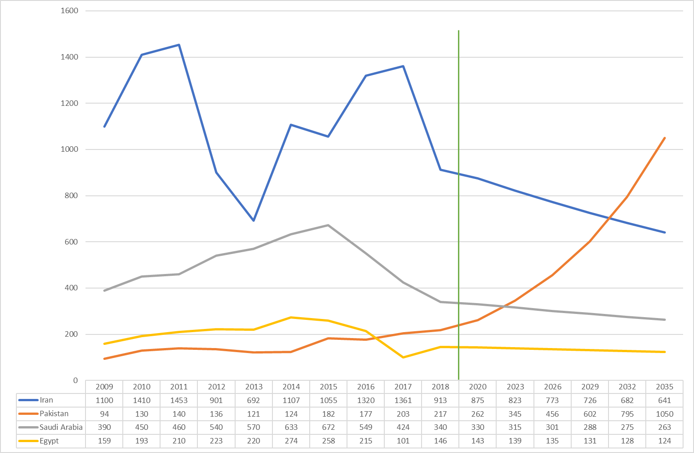
Figure 2: New vehicle sales in Egypt, Iran, Pakistan, and Saudi Arabia, through to 2035 (thousands of units)
Source: OICA, 2020.
Note: The 10-year CAGR (2009-2018) of new vehicles sales for each country was calculated using the sales data from OICA. These growth rates were used to project those markets through to 2035.

Defining hub and spoke opportunities for EAC and Ethiopia

Potential hub opportunities
Based on modelling conducted in Section 2, the most attractive markets in the EAC and Ethiopia are:
- Tanzania, where demand increases from 32,301 units in 2020 to 78,058 units in 2035
- Ethiopia, with demand of 30,380 units in 2020, increasing to 112,814 units in 2035; and
- Kenya, with demand of 80,340 units in 2020, increasing to 174,020 units in 2035.
These three countries appear to be potential candidates for vehicle assembly in the region. Kenya represents the greatest potential, followed by Ethiopia and Tanzania. The following sub-sections provide an overview of each country’s profile and the potential benefit for being part of a regional Automotive Pact.

Kenya
Kenya has a fairly long history of vehicle production that dates back to the 1960s. However, growth in automotive production in Kenya has been stunted by the liberalization of the economy which has allowed cheaper imported pre-owned vehicles. As revealed in Table 6, Kenya is a lower middle income country with a fairly large population. Kenya is the largest and wealthiest economy in East Africa. However, its vehicle market is quite underdeveloped relative to its wealth and population size.
Table 6: Key Kenya automotive indicators
Indicator | Values
Population 2018* | 51 million
GDP per capita PPP 2018 (nominal)* | 1711
Total number of vehicles in operation (2015) † | 1.381 million
Estimated ratio of people to vehicles | 30 per 1,000
Passenger vehicle production (2018ⁱ) | 6 295
Passenger vehicle sales (2016) | 2 400
Commercial vehicle sales (2016) | 8 200
Source: *World Bank http://data.worldbank.org/; †OICA http://www.oica.net/category/vehicles-in-use/; ⁱOICA production and sales http://www.oica.net/category/production-statistics/; http://www.oica.net/category/sales-statistics
Kenya’s GDP growth rate averaged 5.6% over the period 2009 to 2018. This is well above the SSA average of 4.05% and EAC average of 3.65%. Furthermore, Kenya’s GDP per capita growth averaged 2.97% over the same period, with this again well above the SSA and the EAC average of 1.60% and 1.12%, respectively. Despite strong economic growth over the period, only 3% of Kenya’s adult population earned over $10,000 annually in 2017. This represented a total new vehicle consuming population of around 650,000 adults. While Kenya’s strong GDP growth contributed to substantial vehicle demand growth over the period, 2016 to 2018 saw major declines in aggregate demand. This largely affected pre-owned vehicle imports, which declined significantly on peak 2015 levels, as revealed in Figure 3. Both are however projected to recover strongly through to 2035, with new vehicle sales projected to increase from 10,600 units in 2018 to 25,452 units in 2035, and pre-owned vehicle imports from 87,941 to 211,162 units.
Figure 3: Kenyan vehicle demand projections to 2035, based on the existing consumption profile
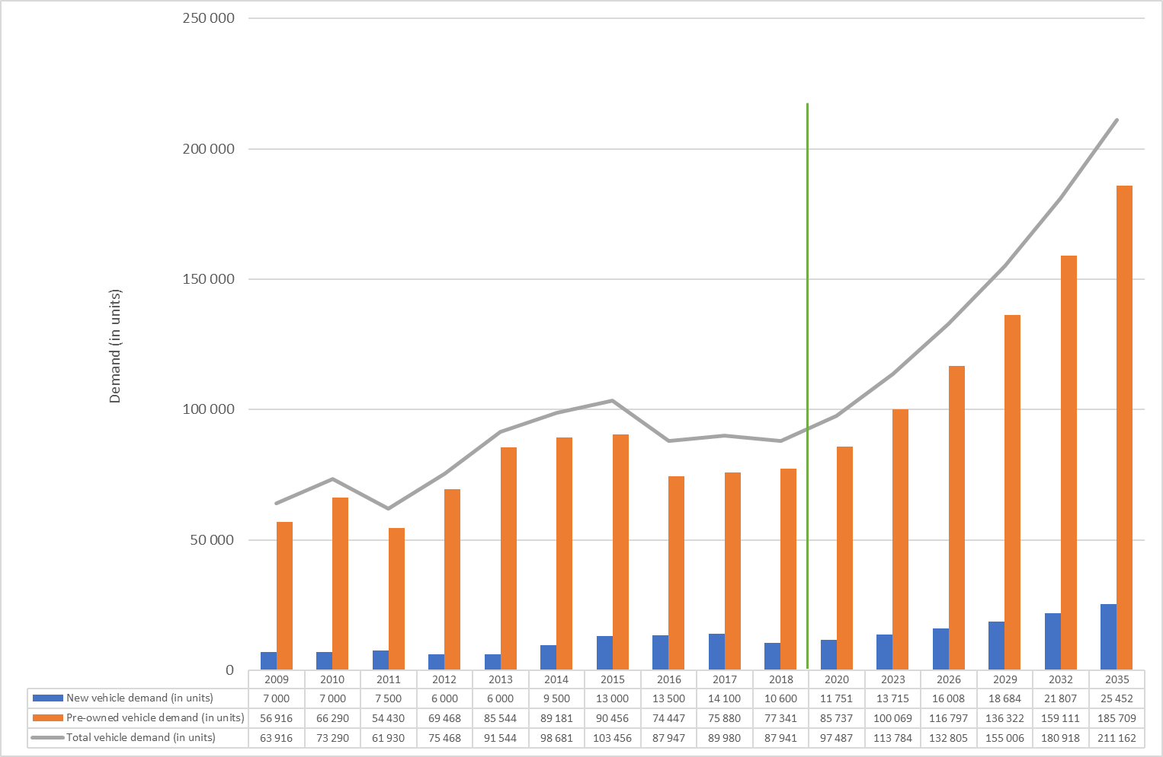
A direct consequence of Kenya’s dependence on pre-owned vehicle imports is a large negative automotive trade balance. Based on our model, Kenya’s deficit will increase to $8.8 billion by 2035 (versus $3.7 billion in 2018). This deficit will place a severe strain on the country’s foreign currency reserves and represents a major drain on Kenya’s economic growth potential.
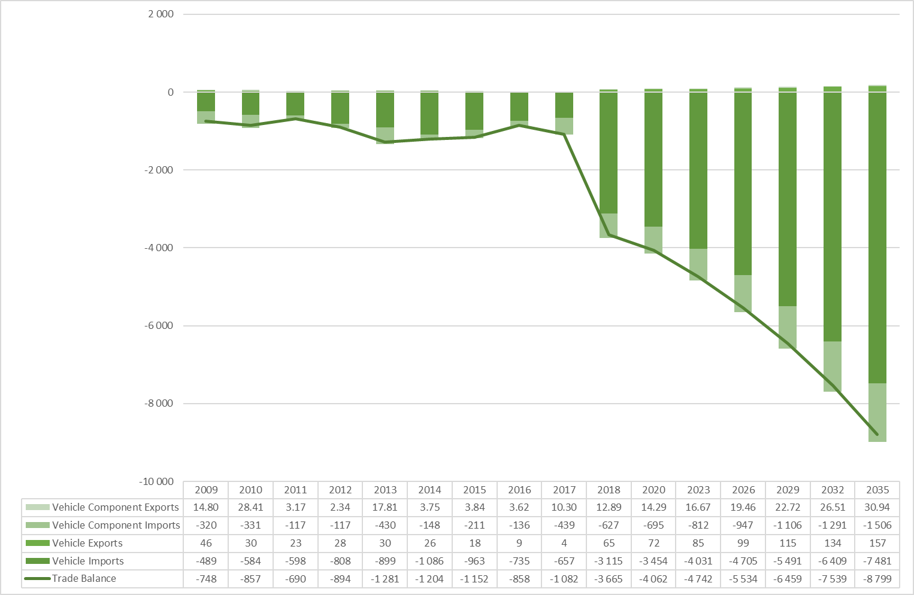
Figure 4: Kenya’s automotive trade balance
Source: UN Comtrade, 2020
If Kenya prohibited the importing of pre-owned vehicles, and the balance of EAC countries were to enact similar legislation, our African Auto Pact model projects new vehicle demand for Kenya of 80,340 in 2020, increasing to 174,020 units by 2035. As further revealed in Figure 5, Kenya is also well located regionally with demand within the EAC and Ethiopia increasing from an imputed 185,307 units in 2020 to 445,176 units in 2035.
Figure 5: Kenya’s adjusted new vehicle demand to 2035 (with no pre-owned vehicle imports)
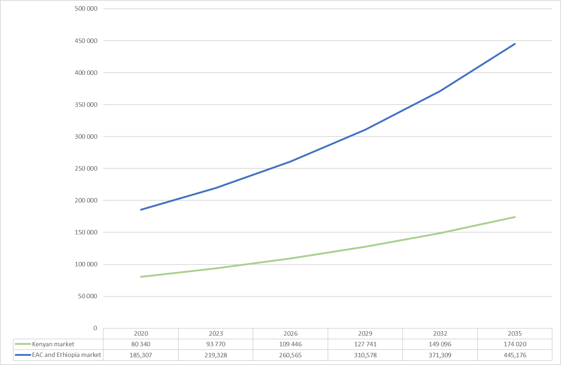
Notes: Based on the termination of pre-owned vehicle imports and substitution with new vehicles (and demand reduced by 20% for affordability reasons).
Based on its own market demand of 174,020 units, and aggregate EAC and Ethiopian demand of 445,176 units, we assess the potential for Kenyan vehicle production of 200,000 units per annum by 2035. The benefits of such production capacity within Kenya is presented in Table 7. Assuming CKD production with 40% local content, 31% local GVA to Kenya (76% of 40% GVA per unit of production) and 9% of GVA to other spoke economies, the production of 200,000 vehicles in Kenya would translate into total annual GVA of $618 million and employment of 15,908 Kenyans. These figures are all substantially greater than what could be achieved through the pursuit of low value-added SKD vehicle assembly operations that would only create 4,478 jobs and limited GVA.
Table 7: Summary of Kenyan opportunities
Production type | Units | GVA per unit | Total GVA | GVA percent of GDP in 2018 | Employment
Semi Knocked Down (SKD): Status quo to 2035* | 174 020 | 4,00% | $67m | 0.11% | 4 478
Completely Knocked Down (CKD): Auto Pact to 2035* | 200 000 | 31,00% | $618m | 1.00% | 15 908
Direct benefit of CKD production to Kenya relative to SKD assembly* | 25 980 | 27,00% | $551m | 0.89% | 6 685
Note: Per assembly of $10,000 vehicle; local market substitution only for SKD; regional market for CKD. * The GVA estimates are understated as they only include the direct economic impact of automotive production and do not factor in the full supply chain – in other words, the GVA estimates exclude an account of downstream activities. GVA contribution is likely to be 6% - 8% of GDP in the hubs as per South Africa.

Ethiopia
As revealed in Table 8, Ethiopia has a large population but its GDP per capita is low. Ethiopia’s vehicle market is quite underdeveloped relative to its population size, as the country has one of the lowest motorisation rates globally, at only two cars per 1,000 inhabitants in 2016. However, the rapid economic growth recently experienced in the country could be a catalyst for the development of the automotive industry.
Table 8: Key Ethiopian automotive indicators
Indicator | Values
Population 2018* | 108 million
GDP per capita PPP 2018 (nominal)* | 772
Total number of vehicles in operation† | 155 000
Estimated ratio of people to vehicles (per 1,000) | 2
Passenger vehicle production (2018ⁱ) | 6 000
Total new vehicle sales (2018) | 8 030
Source: *World Bank http://data.worldbank.org/; †OICA http://www.oica.net/category/vehicles-in-use/; ⁱOICA production and sales http://www.oica.net/category/production-statistics/; http://www.oica.net/category/sales-statistics
Ethiopia’s GDP growth rate averaged 9.8% over the period 2009 to 2018. Again, this is well above the SSA average of 4.05%. Furthermore, Ethiopia experience strong GDP per capita growth over the same period of 6.83%. This is the highest level of GDP per capita growth in Africa over the period and is well above the SSA average.
The United Nations (2020) estimates that the Ethiopian population will grow by approximately 47% by 2035. Consequently, by these estimates, the adult population will grow to 73.6 million adults by 2035. The Ethiopian vehicle market is therefore expected to grow significantly, although job creation will be critical for this potential to be realised. By 2035 there will be approximately 23 million additional adults requiring employment in the country.
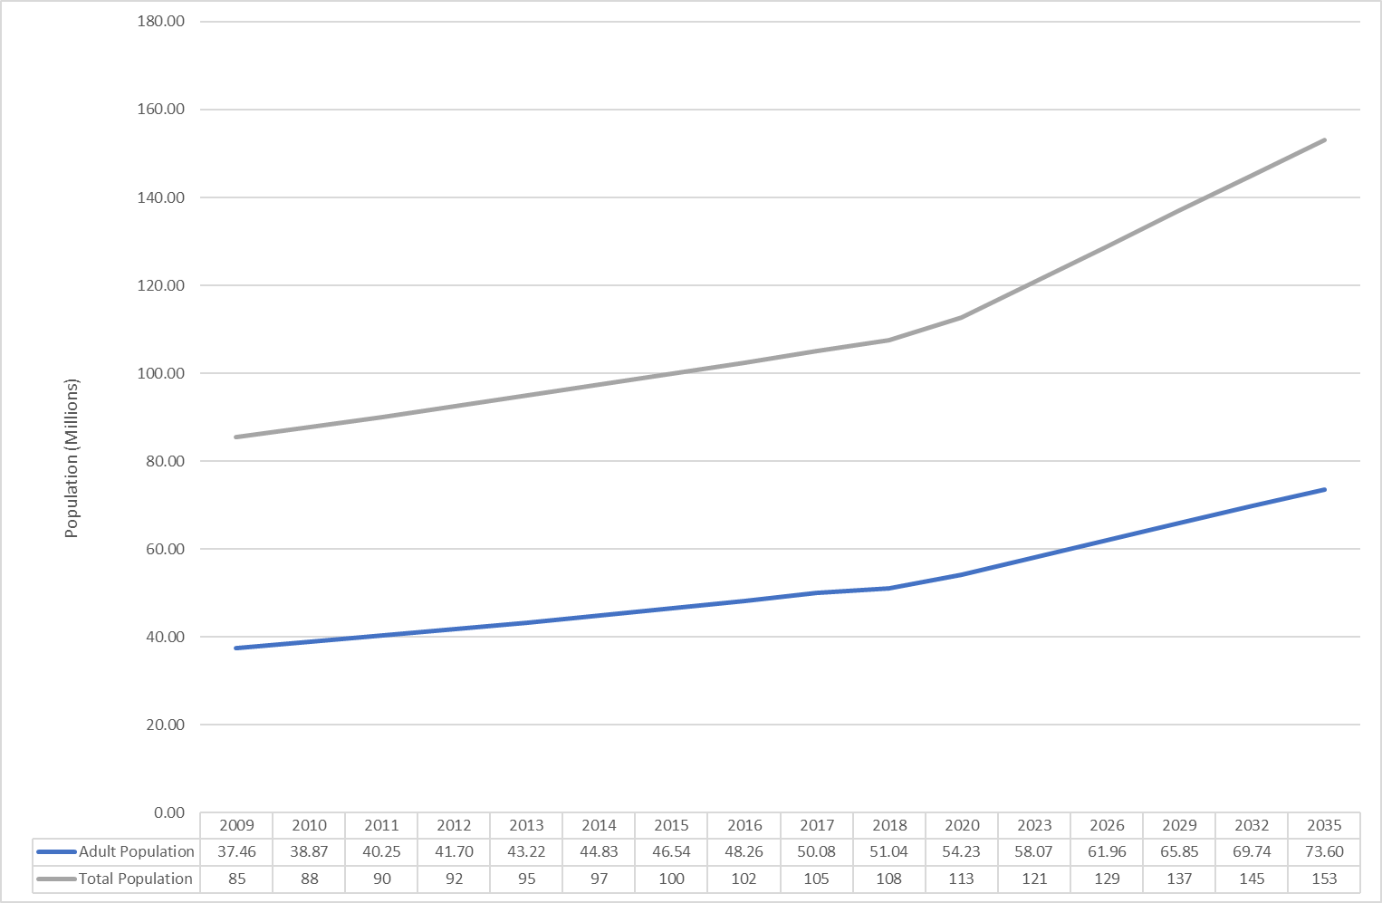
Figure 6: Ethiopia’s population growth rate, 2009 - 2035
Source: UN Database, 2020; Credit Suisse Databooks,2010-2019
Based on Ethiopia’s present economic growth trajectory, we expect large growth in the proportion of adults earning above $10,000 by 2035. As revealed in Figure 7, given the anticipated economic growth and the absolute growth in population, the number of adults able to purchase vehicles will increase from only 2.39 million adults in 2017 to 11.2 million in 2035. This will spur large increases in the demand for new vehicles.
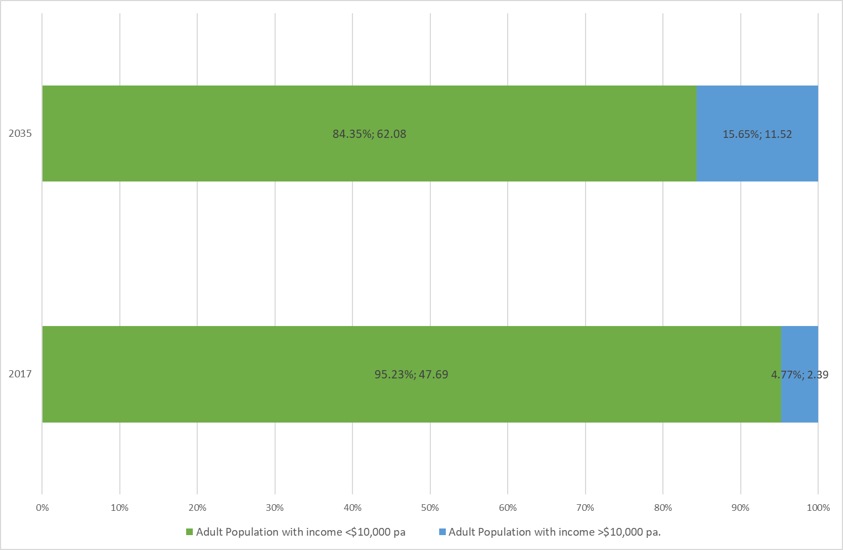
Figure 7: Ethiopia adult population earning income above $10,000, 2017 and 2035
Source: UN Database, 2020; Credit Suisse Databooks,2010-2019
Ethiopia’s automotive market is dominated by pre-owned imported vehicles. However, Ethiopia’s new vehicle market accounts for 27% (8,090 vehicles) of the vehicle market compared to Kenya where the new vehicle market accounts for only 12% of the vehicle market (inclusive of pre-owned imports). Based on its current trajectory. Ethiopia’s total vehicle sales are estimated to reach 132,137 units in 2035. Most of these sales will be of pre-owned vehicle imports (96,618 units), with the new vehicle market reaching only 35,519 units. Per the Kenyan outlook, if Ethiopia continues this current trajectory its automotive consumption profile will become untenable.
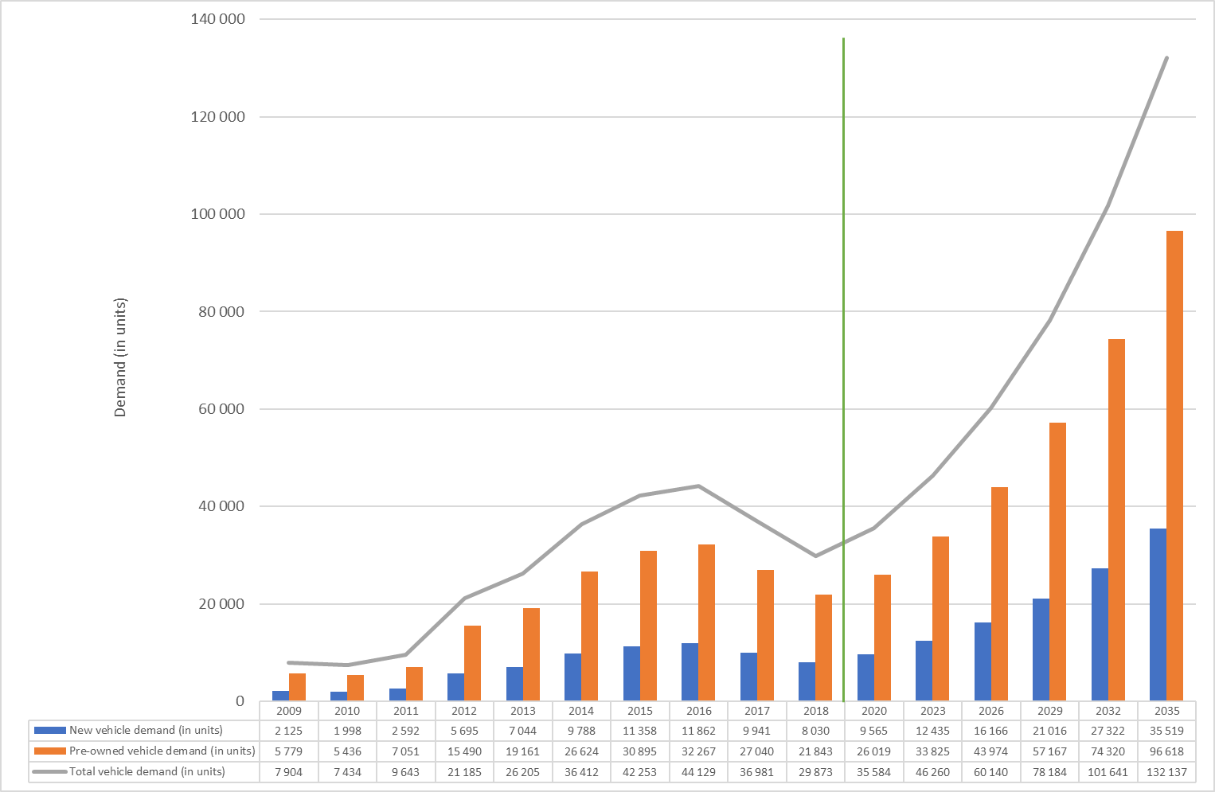
Figure 8: Ethiopian vehicle demand projections to 2035, based on the existing consumption profile
A direct consequence of Ethiopia’s continued dependence on pre-owned vehicle imports is a deteriorating automotive trade balance, which will shift from a deficit of $277 million in 2018 to a deficit of $1.2 billion by 2035.
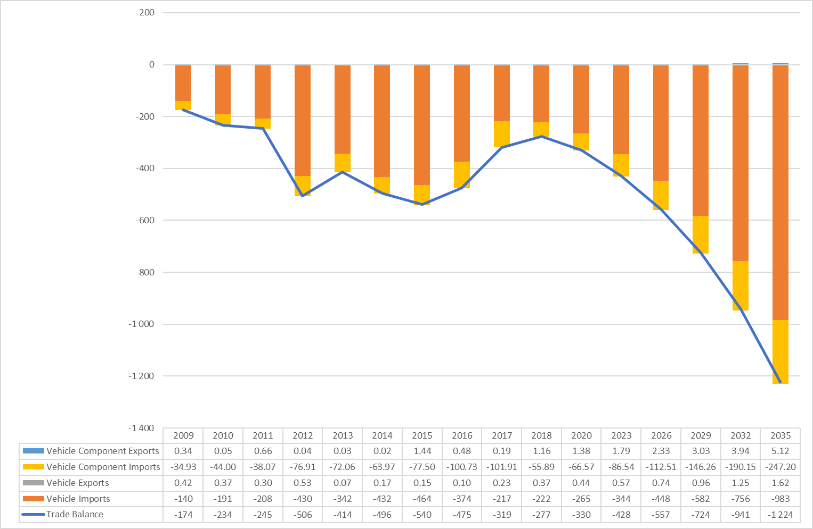
Figure 9: Ethiopia’s automotive trade balance
Source: UN Comtrade, 2020
If Ethiopia were to join Kenya and other EAC countries in prohibiting imports of pre-owned vehicles, our African Auto Pact model projects new vehicle demand for Ethiopia of 30,380 in 2020, increasing to 112,814 units by 2035. As further revealed in Figure 10, when Ethiopia’s volumes are added to the EAC total, substantial regional demand is realised - from an imputed 185,307 units in 2020 to 445,176 units in 2035.
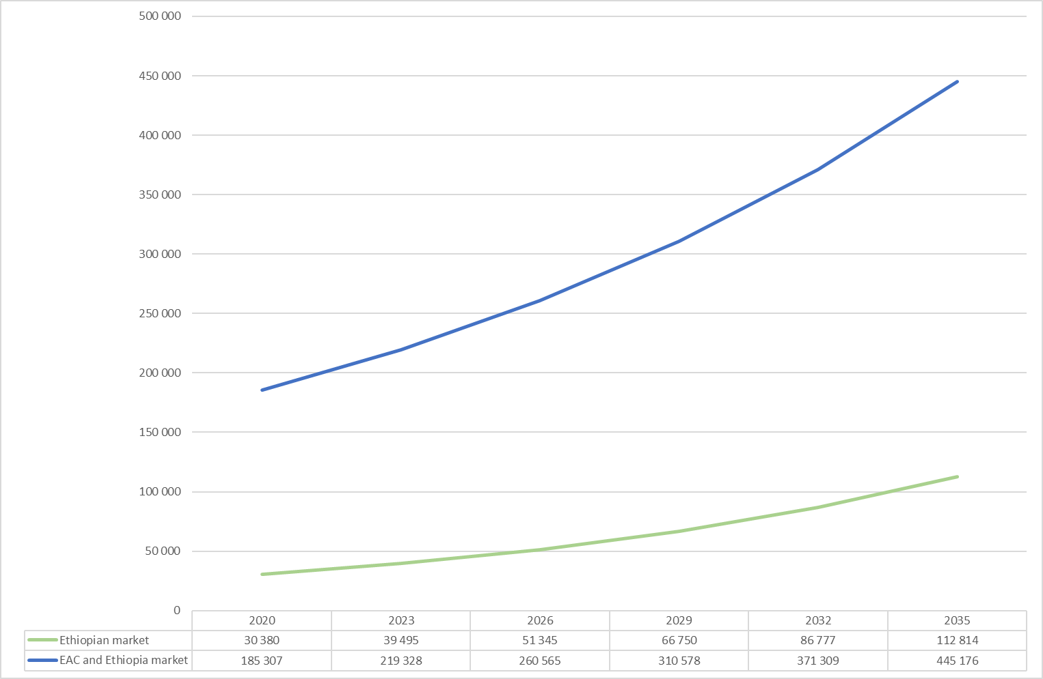
Figure 10: Ethiopia’s adjusted new vehicle demand to 2035 (with no pre-owned vehicle imports)
Notes: Based on the termination of pre-owned vehicle imports and substitution with new vehicles (and demand reduced by 20% for affordability reasons).
Based on its own market demand of 112,854 units, and broader EAC demand of 445,176 units, we assess the potential for Ethiopian vehicle production of 150,000 units per annum by 2035. The benefits of such production capacity within Ethiopia is presented in Table 9. Assuming CKD production with 40% local content, 31% local GVA for the hub Ethiopia (76% of 40% GVA per unit of production) and 9% local GVA for the other spoke economies, the production of 150,000 vehicles in Ethiopia would translate into total annual GVA of $463 million and employment of 11,931 Ethiopians. These figures are all substantially greater than what could be achieved through the pursuit of low value-added SKD vehicle assembly operations.
Table 9: Summary of Ethiopian opportunities
Production type | Units | GVA per unit | Total GVA | GVA percent of GDP in 2018* | Employment
Semi Knocked Down (SKD): Status quo to 2035* | 112 854 | 4,00% | $44m | 0.07% | 2 903
Completely Knocked Down (CKD): Auto Pact to 2035* | 150 000 | 31,00% | $463m | 0.74% | 11 931
Direct benefit of CKD production to Ethiopia relative to SKD assembly* | 37 146 | 27,00% | $419m | 0.67% | 9 028
Note: Per assembly of $10,000 vehicle; local market substitution only for SKD; regional market for CKD. * The GVA estimates are understated as they only include the direct economic impact of automotive production and do not factor in the full supply chain – in other words, the GVA estimates exclude an account of downstream activities. GVA contribution is likely to be 6% - 8% of GDP in the hubs as per South Africa.

Tanzania
As revealed in Table 10, Tanzania is a lower income country with a fairly large population. As per Kenya and Ethiopia, its vehicle market is underdeveloped relative to its wealth and population size.
Table 10: Key Tanzania automotive indicators
Indicator | Values
Population 2018 | 59 million
GDP per capita PPP 2014 (nominal)* | 1 051
Total number of vehicles in operation† | 380 000
Estimated ratio of people to vehicles (per 1000 people) | 7 per 1000
Passenger vehicle production (2015ⁱ) | -
Passenger vehicle sales (2016) | 2 300
Commercial vehicle sales (2016) | 2 200
Source: *World Bank http://data.worldbank.org/; †OICA http://www.oica.net/category/vehicles-in-use/; ⁱOICA production and sales http://www.oica.net/category/production-statistics/; http://www.oica.net/category/sales-statistics

Tanzania’s GDP growth rate averaged 6.3% over the period 2009 to 2018. Again, this is well above the SSA average of 4.05%. However, given its rapidly growing population, Tanzania’s GDP per capita growth over the same period has been more moderate at 3.13%.
The United Nations (2020) estimates that the Tanzanian population will grow by approximately 62% by 2035. The adult population will grow from 26 million in 2018 to 42 million. The Tanzanian vehicle market is therefore expected to grow significantly.
Figure 11: Tanzania’s population growth rate, 2009 - 2035
Source: UN Database, 2020; Credit Suisse Databooks,2010-2019
Based on Tanzania’s present economic growth trajectory, we project a modest growth in the proportion of adults earning above $10,000 by 2035. As revealed in Figure 12, given the anticipated economic growth and the growth in the population the absolute number will, however, grow from 1.34 million adults in 2017 to 3.86 million in 2035. This will spur increases in the demand for new vehicles.
Figure 12: Tanzania’s adult population earning income above $10,000, 2017 and 2035
Source: UN Database, 2020; Credit Suisse Databooks,2010-2019
Tanzania currently has a relatively small new vehicle market. As shown in Figure 13, Tanzania new vehicle demand was only 4,500 units in 2018. There were an estimated 30,270 pre-owned vehicle imports in the same year. Based on its current trajectory, Tanzania’s total vehicle sales are estimated to reach 94,515 units in 2035. Most of these sales will be of pre-owned vehicle imports (82,283 units), with the new vehicle market reaching only 12,232 units. Therefore, if Tanzania continues this current trajectory its automotive consumption profile will become untenable.
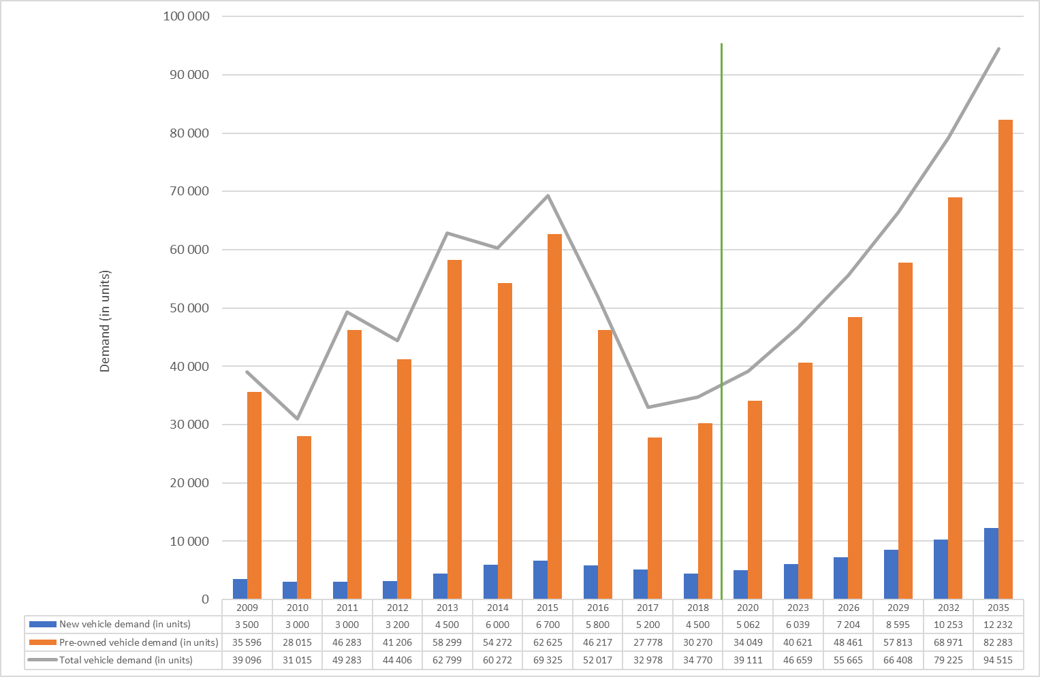
Figure 13: Tanzania’s vehicle demand projections to 2035, based on the existing consumption profile
A direct consequence of Tanzania’s increased dependence on pre-owned vehicle imports it its automotive trade balance weakening substantially; from a deficit of $369 million in 2018 to a deficit of $1 billion by 2035.
Figure 14: Tanzania automotive trade balance
Source: UN Comtrade, 2020
If Tanzania were to join Kenya and other EAC countries in prohibiting imports of pre-owned vehicles, the African Auto Pact model projects new vehicle demand for Tanzania of 32,301 in 2020, increasing to 78,058 units by 2035.
Figure 15: Tanzania adjusted new vehicle demand to 2035 (with no pre-owned vehicle imports)
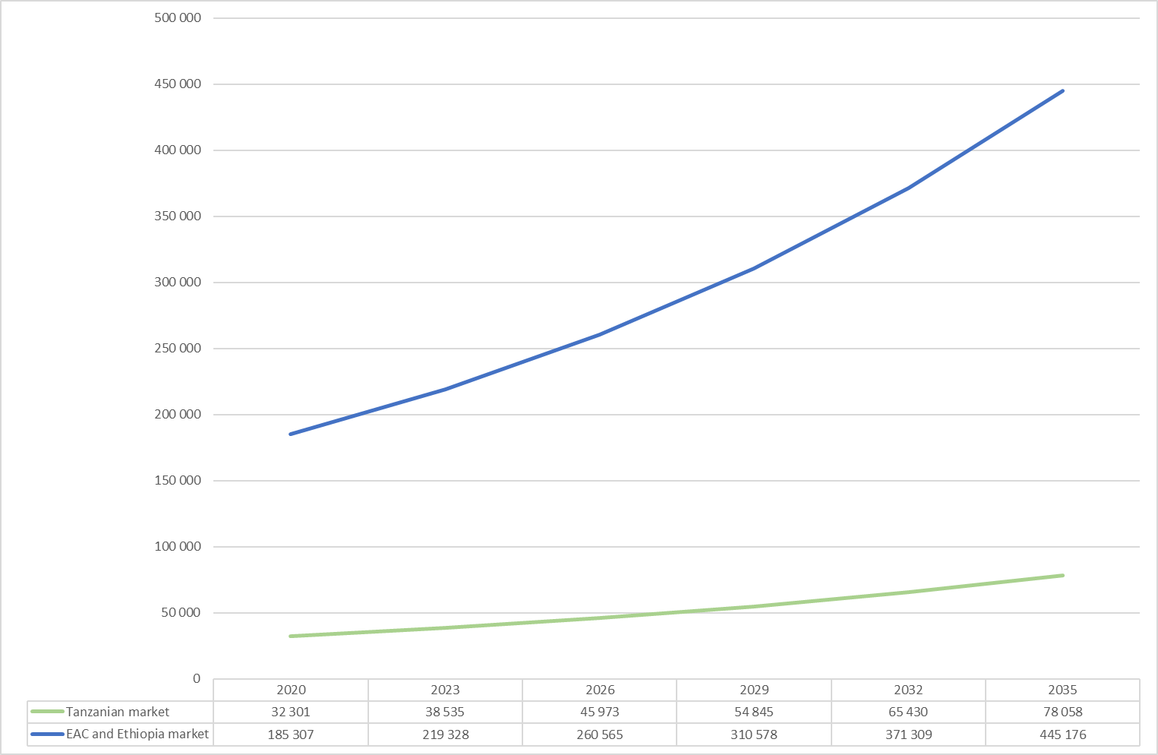

Notes: Based on the termination of pre-owned vehicle imports and substitution with new vehicles (and demand reduced by 20% for affordability reasons).
Based on its own market demand of 78,058 units, and broader EAC demand of 445,176 units, we assess the potential for Tanzanian vehicle production of 100,000 units per annum by 2035. The benefits of such production capacity within Tanzania is presented in Table 11. Assuming CKD production with 31% (76% of 40% GVA per unit of production) local GVA, the production of 100,000 vehicles in Tanzania would translate into total annual GVA of $309 million and employment of 7,954 Tanzanians by 2035. These figures are all substantially greater than what could be achieved through the pursuit of low value-added SKD vehicle assembly operations.
Table 11: Summary of Tanzanian opportunities
Production type | Units | GVA per unit | Total GVA | GVA percent of GDP in 2018* | Employment
Semi Knocked Down (SKD): Status quo to 2035* | 78 058 | 4,00% | $30m | 0.06% | 2 009
Completely Knocked Down (CKD): Auto Pact to 2035* | 100 000 | 31,00% | $309m | 0.59% | 7 954
Direct benefit of CKD production to Tanzania* | 21 942 | 27,00% | $279m | 0.53% | 5 945
Note: Per assembly of $10,000 vehicle; local market substitution only for SKD; regional market for CKD. * The GVA estimates are understated as they only include the direct economic impact of automotive production and do not factor in the full supply chain – in other words, the GVA estimates exclude an account of downstream activities. GVA contribution is likely to be 6% - 8% of GDP in the hubs as per South Africa.

Broader EAC opportunities
It is likely that assembly and time sensitive manufacturing will occur within the hub economies of the EAC. However, the broader members of the EAC have the potential to operate as spoke economies, and are therefore well placed to benefit from being part of the Pact through access to the pact fleet, establishment of componentry and aftermarket activity and through mutual trade of complementary automotive products such as motorcycles and yellow metal transport machinery.

Direct economic benefits
If an EAC and Ethiopian automotive pact is successfully implemented, with the region meeting the PEM production estimates of around 450,000 units annually by 2035. We estimate that the automotive industry will contribute a potential of $406 million in GVA in the spoke economies by 2035.
Based on this GVA, all of which would represent foreign exchange savings and a positive contribution to the region’s trade balance, the spoke economies could employ 9,227 people in component manufacturing operations (for the vehicle assemblers), with a further 1,845 employed in aftermarket related component activities.
Table 12: Direct benefit to spoke economies in 2035
 | Adjusted  annual units of demand | GVA  ($millions) | GVA Percent of GDP in 2018* | Employment at component manufacturers | Aftermarket Component Employment spill over | Total Industry Employment estimate
Burundi | 2 938 | 53 | 2.27% | 1 216 | 243 | 1 459
Rwanda | 4 818 | 31 | 0.31% | 705 | 141 | 846
South Sudan | 1 648 | 84 | n/a | 1 903 | 381 | 2 283
Uganda | 70 879 | 238 | 0.78% | 5 403 | 1 081 | 6 484
Total | 80 284 | 406 | n/a | 9 227 | 1 845 | 11 072
*The GVA estimates are understated as they only include the direct economic impact of automotive production and do not factor in the full supply chain – in other words, the GVA estimates exclude an account of downstream activities.

Potential component benefits
Trade data suggests that there are currently very limited existing component capabilities in the EAC spoke economies, with most automotive components imported. As shown in Table 13:
- Burundi exported about $90,000 worth of miscellaneous parts in 2018 (HS 8708). Exports of rubber tyres for buses and heavy commercial vehicles were small ($24,000) but have grown by 9% CAGR over the past decade.
- Uganda exported around $992,000 worth of vehicle parts and accessories (HS 8708) in 2018, of which $700,000 were miscellaneous P&A, and $978,000 were new pneumatic rubber tyres used on buses or lorries. Uganda’s exports of chassis’ is much smaller, at only $22,000.
- There is no component trade data for Rwanda in 2017 and 2018. However, 2016 data suggests that Rwanda potentially may have some capabilities in miscellaneous P&A and in producing tyres for motor cars.
Table 13: Spoke economy component trade performance
Components | Burundi |  |  |  | Uganda |  |  | Rwanda
Components | Exports  2018 | 10-yeart  CAGR | TB  2018 | Export  2018 |  | 10-year  CAGR | TB  2018 | Export  2016 | 9-year  CAGR | TB  2016
Chassis; fitted with engines (HS 8706) | - | - | - | 22 479 |  | 31% | -14 014 | - | - | -99 088
Parts and accessories of the motor vehicles (HS 8708) | 90 347 | -17% | -3 772 526 | 992 603 |  | 7% | -18 774 919 | 56 252 | -16% | -7 547 196
New pneumatic rubber tyre for motor cars (HS 401110) | 23 093 | - | -1 245 728 | 165 155 |  | -8% | -20 393 397 | 53 824 | 38% | -4 601 966
New pneumatic rubber tyres used on buses or lorries (HS 401120) | 24 318 | 9% | -4 653 917 | 976 567 |  | 6% | -22 681 822 | 17 534 | -10% | -4 940 324
Glass suitable for incorporation in vehicles (HS 700721) | - | - | -35 164 | 9 366 |  | 54% | -623 160 | - | - | -105 180
Electrical windscreen wipers, defrosters, and demisters (HS 851240) | - | - | -353 | 1 094 |  | -5% | -87 528 | - | - | -50 112
Vehicle parts; radiators and parts thereof (HS 870891) | 119 | - | 119 | 6 284 |  | -24% | -226 379 | 23 | -41% | -158 325
Source: UN Comtrade, 2020
Note: No component data for Rwanda in 2017 and 2018.

Motorcycle capabilities
As a region, the EAC and Ethiopia has maintained a large trade deficit on motorcycles. As shown in Figure 16 below, exports of motorcycles in 2018 amounted to around 23,000 units whereas the region imported 378,000 units in the same year. The trade deficit has grown over the past decade, as exports have declined by a CAGR of 8% from 2009 to 2018; whereas imports have grown by a CAGR of 12%.

Figure 16: EAC and Ethiopian trade balance of motorcycles, units (2009 – 2018)
Source: UN Comtrade, 2020
As shown in Figure 17, the largest motorcycle trade deficits are for Kenya, Ethiopia, and Uganda. These three countries collectively imported 90% of the imported motorcycles in the region or about 540,000 units in 2018. Uganda is the only country with significant exports of motorcycles in 2018. It exported about 21,000 motorcycles in 2018.
Figure 17: EAC and Ethiopian trade balance of motorcycles by country, units (2018)
Source: UN Comtrade, 2020

Agriculture, mining, and construction equipment capabilities
Off-highway agricultural, mining and construction vehicle manufacturing has potential linkages to vehicle manufacturing and can be a complementary source of industrialisation alongside a passenger and commercial vehicle manufacturing industry. The product range of agriculture, mining, and construction equipment include various types of machinery operated as a vehicles, including the broad set of products listed in Table 14 below.
Segment | Product range
Agriculture | Articulated Tractor, Cane Loader, Agricultural Forklifts, Haulage Tractors
Forestry | Feller Buncher, Forwarder, Harvester, Logger, Long Range Forwarder, Skidder, Timber Trucks
Mining & Construction | Articulated Dump Truck (ADT), Crawler Dozer, Excavator, Motor Grader, Tipper Trucks, Tractor Loader Backhoe (TLB), Wheeled Loader
Construction | Asphalt Construction, Cold Milling / Stabilizer and Recycler, Crushing and Screening, Concrete Mixer, Fire Truck, Hooklift Truck, Cranes, Container Handler, Custom Load Bodies, Rock scaler, TLB Variations, Water Tankers
Table 14: Range of agriculture, mining, and construction equipment products
Note: For specific HS code definition, refer to Annexure 2
Currently, South Africa is the only country with its own domestic OEMs manufacturing agriculture, mining, and construction equipment, with the rest of the continent hosting distributors of imported products such as AB Volvo, Caterpillar Inc., Deere & Company, Doosan Infracore, Hitachi, Ltd., J C Bamford Excavators Ltd, Kobelco Construction Machinery Co., Ltd., Komatsu Ltd., SANY Group, and Xuzhou Construction Machinery Group Co., Ltd. (XCMG). The continued mineral discoveries and increasing rates of urbanisation in Africa, however, suggest that this market has the potential to support the significant expansion of the Yellow Metals industry. Figure 18 below shows the exports of agriculture, mining, and construction equipment by country in 2018.
Figure 18: EAC and Ethiopian exports and imports of agriculture, mining, and construction equipment by country, units (2018)
Source: UN Comtrade, 2020
As shown in Figure 18, Ethiopia is the only significant exporter of agriculture, mining, and construction equipment in the region, exporting over a million units of machinery in 2018. Ethiopian exports spiked significantly from 2017. The key agriculture, mining, and construction equipment export segments for Ethiopia are construction machinery (bulldozers, excavators, graders, and loaders), tractors and off-highway dump trucks.
The strong exports of agriculture, mining, and construction equipment by Ethiopia is likely through Bishoftu Automotive Engineering Industry (which will be discussed more in section 4). Market research suggests that the heavy equipment market in Ethiopia and Djibouti was approximately $323.9 million in 2018 and is projected to reach $496.1 million in 2026, growing at a CAGR of 5.6% (Allied Market Research, 2020). Growth in demand has been driven by infrastructure development both in the public and private sectors. The large size of the agriculture, mining, and construction equipment market in Ethiopia provides an opportunity for the introduction of agriculture, mining, and construction equipment within the African Auto Pact arrangement.

EAC-Ethiopia trade and market dynamics

EAC trade and market dynamics
The East African Community (EAC) regional partnership was formed in 2000 and consists of Burundi, Kenya, Rwanda, Tanzania, Uganda, and South Sudan. The EAC is one of the most sophisticated regional trade agreements in Africa as the region has established a Free Trade Area (FTA), Customs Union (CU), and Single Market for trade of goods. Under the EAC Customs Union Protocol, member countries agreed to remove all existing non-tariff barriers (NTBs) to intra-EAC trade, and to refrain from imposing new ones.
The current EAC Common External Tariff (CET) is based on three bands: 25% for finished goods, 10% for intermediate goods and 0% for raw materials and capital goods, with a limited number of products which are considered “sensitive goods” and thus attract rates above the maximum 25% (EAC, 2020). CBU vehicles are considered finished goods and therefore are charged a 25% duty whereas vehicle components are charged a 10% duty.
The EAC CET is currently under review, with members considering higher rates of external protection and an increase in the number of tariff bands (East African Business Council, 2020). On the 1st February 2020, EAC Partner States held an EAC Regional Task Force (RTF) meeting: Meeting to undertake Comprehensive Review of the EAC CET. The following resolutions were made during the meeting:
- Members agreed on a four-band tariff structure of 0%, 10%, 25% and a rate above 25%, either to be 30% or 35%.
- Members agreed on the criteria for classifying and categorizing of goods in four categories which are:
  - Category 1: comprising raw materials and capital goods.
  - Category 2: comprising intermediate goods.
  - Category 3: comprising finished goods.
  - Category 4: comprising goods for differentiated categorisation. Category 4 includes goods that are “meritorious goods which are based on social and humanitarians considerations, goods for dual use and goods which may not be sufficiently accommodated in the CET and could require special policy measures”(East African Business Council, 2020:3).
On considering whether the maximum CET rate should be either 30% or 35%, Tanzania and Uganda maintained 35% while Rwanda was in favour of 30% as a maximum rate. Burundi and Kenya reported that they are still undertaking national consultations on the upper limit and will notify the EAC Secretariat on the outcome of the consultations before the next RTF meeting (East African Business Council, 2020).
In addition to converging trade measures, the EAC seeks to promote a single investment area; its Treaty calls for the harmonisation and rationalisation of investment incentives, including those relating to taxation of industries. However, the legal and institutional frameworks for investment remain country specific. The following sub-sections outline the various country specific initiatives that have been undertaken to develop an automotive industry in the EAC.

Kenya
In the early 1980s, Kenya banned the importation of CBUs. However, following a World Bank-imposed structural adjustment programme (SAP) in mid-1990s, the country subsequently removed many trade restrictions and the economy underwent liberalisation, allowing the importation of CBUs. As no age limit was imposed on vehicles imported, pre-owned imports flooded the market. It is currently estimated that approximately 80% of Kenya’s total vehicle fleet comprises pre-owned vehicle imports (Black et al., 2017).
The country has three local assemblers, the Isuzu plant in Nairobi, the Associated Vehicle Assemblers (AVA) plant in Mombasa and the Kenya Vehicle Manufacturers (KVM) plant in Thika. These assemblers collectively produce around 6,000 cars per annum, but they are operating significantly below installed capacity. As shown in Table 15, the national average capacity utilisation of auto manufacturing plants is at 20%.
Table 15: Kenya motor assembly plants capacity utilisation
Assembly plant | Brands and franchise holder |  | Capacity utilization
Isuzu East Africa Limited  Nairobi | ISUZU EA–Isuzu |  | 23%
Associated Vehicle Assemblers  Mombasa | SIMBA CORP– Mitsubishi, FUSO  TATA – Tata  Toyota East Africa – Toyota, Hino  Kenya Grange – Scania  Foton – Foton, Aumark  Volvo – Volvo  Daewoo |  | 35%
Kenya Vehicle Manufacturers (KVM) Thika | COOPER MOTORS CORPORATION - Nissan Diesel, Eicher, MAN  Crown Motors – Nissan  Peugeot (PSA Group) – Peugeot  Volkswagen – Volkswagen  Bus Body Building - 33-seater bodies for Hyundai, Eicher, Isuzu, Mitsubishi; 51-seater bodies for UD, TATA, Hino; 62-seater bodies for Scania, MAN, Ashok Leyland |  | 2%
National Average Utilization |  | 20%
Source: Kenya National automotive Policy (2019)
The Kenyan government identified the automotive and auto parts industry as a major driver economic development in the Kenya National Industrialisation Policy Framework released in 2010. Subsequently, Kenya has been making efforts to revive its automotive industry, including introducing an 8-year age limit on used vehicle imports and recently developing a Draft National Automotive Policy.

Tanzania
IPP Automobile Company Ltd signed an agreement with a South Korean firm, Youngsan Glonet Corporation, in 2018 to set up a vehicle assembly plant in the Tanzania (Forbes, 2018). A manufacturing plant was anticipated to be built in Kurasini in Dar es Salaam. The $10 million facility is expected to assemble around 1,000 vehicles per year, including commercial and construction trucks, buses, and sports utility vehicles (SUVs). The plant is expected employ more than 1,000 people including distribution and sales executives in Tanzania, Rwanda, Kenya, Uganda, Zambia, and Malawi. IPP Automobile Company has already begun importing parts for the assembly of Hyundai, Kia, and Daewoo vehicles.

Rwanda
VW established a Semi-Knocked Down (SKD) car assembly plant in Rwanda in 2018. The VW model will be used for a VW taxi fleet, that is then used as part of a VW-mobility platform that provides citizens with a platform-based taxi service that is located and optimised in Rwanda, and that is supported by an advanced service workshop that ensures the VW platform-fleet is in good running condition. Such a model has enabled the introduction of limited vehicle assembly, improvements to the country’s mobility services, the creation of a digital taxi-platform, and the introduction of advanced vehicle maintenance services. The plant is currently producing the VW Polo model in the first phase but VW plans to reach annual production of 5,000 cars by also building its Passat, Tiguan, Amarok and Teramont models in the plant. The assembly plant uses components shipped from South Africa to Rwanda. The $20 million investment is expected to create up to 1,000 jobs (Reuters, 2018).

Ethiopia trade and market dynamics
Ethiopia's accession to the World Trade Organization (WTO) has been underway since 2003 (ITA, 2020). While the government has put a renewed emphasis on WTO accession, the timeline for completing the process remains unclear. Ethiopia is also a signatory to the following trade agreements:
- The Common Market for Eastern and Southern Africa (COMESA) Treaty
- The Intergovernmental Authority on Development (IGAD) Agreement
- The European Union (EU) Economic Partnership Agreement (EPA) as part of the African, Caribbean, and Pacific (ACP) Group States
- Ethiopia has also signed and ratified the Abuja Treaty that aims to establish an Africa Continental Free Trade Agreement (AfCFTA).
The general rate of customs duty into Ethiopia ranges from 0% to 35%. Other taxes may also be imposed on imports, such as an excise tax. As shown in Table 4 below shows Ethiopia’s current automotive duty structure. Note that passenger vehicles have the highest duty rate of 35%, an excise duty of 30% and are also subject to VAT and surcharge taxes. Given that taxes are cumulative in Ethiopia, excise tax is calculated on the customs duty, surtax is charged on top of the excise tax, and customs duty and final VAT is calculated once the surtax, excise tax and customs duty have been added. Therefore, cumulative taxes on imported vehicles may accumulate to as much as 200% depending on the type of vehicle.
Table 16: Ethiopia’s automotive tariff structure
HS Code | HS Description | Duty Tax Rate (%) | Excise Tax Rate (%) | VAT Rate (%) | Sur Tax Rate (%)
8702 | Buses | 35 | 0 | 15 | 0
8703 | Passenger vehicles | 35 | 30 | 15 | 10
8704 | Commercial vehicles | 10 | 0 | 15 | 0
8707 | CKD tariffs | 30 | 0 | 15 | 10
8711 | Motorcycles | 30 | 0 | 15 | 10
Source: Ethiopia Revenue and Customs Authority, 2017
Given that the current tax regime governing vehicle excise and surtax does not distinguish between imported or locally assembled vehicles, these taxes do not provide any incentive for establishing local assembly or manufacturing but rather serves as a revenue generation mechanism for the government.
Goods imported from COMESA members are granted between 0% to 10% tariff preference, depending on the goods. Ethiopia plans to become a full COMESA FTA member by 2021 (ITA, 2020). This combination of high external duties and the ambition of Ethiopia to join the COMESA and EAC, are significant enablers for Ethiopia to form part of a regional automotive pact with the EAC.
It is estimated that Ethiopia produced around 6,000 passenger vehicles in 2018. There are no available estimates for other vehicle types. However, the major automotive assembly plants in Ethiopia, according to Deloitte (2018), are shown in Table 17 below.
Table 17: Major automotive assemblers in Ethiopia
Assembler | Location | Annual capacity | Brands | Type of vehicle
Bishoftu Automotive Industry (BAI) | Bishoftu | 4 000 | Bishoftu, FAW | Passenger vehicles, LCV, HCV
Betret International | Adama | 1 200 | BYD Auto | Passenger vehicles
Yang Fan Dukem | Eastern Industry Zone | 1 000 | Lifan | Passenger vehicles
Mesfin | Industrial Engineering Mekelle | 1 000 | Geely Passenger vehicles license | Passenger vehicles
Automotive Manufacturing Company of Ethiopia (AMCE) | Addis Ababa | 600 | IVECO | HCV
Belayab Engineering | Adama | 500 | FAW | HCV
Nigma Motors and ZAZ | Gulele | 300 | Nigma (produce Daewoo, Chevrolet under license) | Passenger vehicles
Source: Deloitte (2018)
All current Ethiopian assembly is in the form of SKD production. Although a number of assemblers’ source some components such as tyres locally, Ethiopia has no defined local content requirement (Deloitte, 2018).
Bishoftu Automotive Industry (BAI) is the largest automotive manufacturer in Ethiopia. BAI is a manufacturer and assembler of heavy armament, tanks, and military vehicles. It is one of the institutions of the Ethiopian National Defence Force. BAI has the following five divisions:
- Military Vehicles manufacturing (light and heavy trucks used by the Ethiopian ground forces)
- Motor manufacturing and mechanical workshop (manufacturing engines and produces spare parts for tanks, armoured vehicles, and military trucks)
- Tanks and armoured vehicles manufacturing Rebuild of all tanks and armoured vehicles used by Ethiopian forces.
- Medium and heavy weapons manufacturing and electroplating
- Communications Apparatus manufacturing and maintenance
Several private sector players perceive BAI to be difficult to compete against as state supported assemblers’ benefit from government projects (Deloitte, 2018).
Ethiopia has pursued an interventionist industrial policy since the early 2000s with a large set of policy instruments to promote diversification and industrialisation. This included the development of five-year plans such as the current Growth and Transformation Plan II (GTP II, 20014/15 - 2019/20). The countries industrial policy instruments include industrial parks, industrial financing, and export promotion strategies. The current GTP II aims to support and grow the manufacturing contribution to GDP from 4% in 2014 to 8% by 2020. In efforts to develop the automotive industry, the government of Ethiopia recently signed a memorandum of understanding (MoU) with Volkswagen (VW) which seeks to seize opportunities in vehicle assembly facilities and localising automotive components in Ethiopia.

Summary of findings and recommendations
In summary, the EAC and Ethiopia region presently has an aggregate population size of around 300 million and is expected an additional 150 million inhabitants and is expected to have some of the most densely populated cities in Africa. This presents a significant opportunity for growth of automotive industry as a driver of industrialisation. However, the region only sold about 30,000 new vehicles in 2018 and only produced approximately 12,000 vehicles. Pre-owned vehicle imports and a plethora of small, disconnected domestic markets ensure that there is limited scope for the creation of a sustainable, large scale automotive industry in the region.
The elimination of pre-owned vehicle imports will have a significant impact on new vehicle demand in the EAC and Ethiopia, with new vehicle demand potentially reaching 445,176 units in 2035 (assuming the full elimination of pre-owned vehicle imports). The most attractive markets in the EAC and Ethiopia are:
- Kenya, with demand of 80,340 units in 2020, increasing to 174,020 units in 2035.
- Tanzania, where demand increases from 32,301 units in 2020 to 78,058 units in 2035; and
- Ethiopia, with demand of 30,380 units in 2020, increasing to 112,814 units in 2035.
Based on the 2016 economic profile of the South African automotive industry, and new vehicle demand in the region of 445,176 units in 2035, the following socio-economic benefits can be projected for the development of a CKD-based regional automotive industry that produces the same number of vehicles sold in the market: additional GVA of $1.78 billion, and the creation of 46,482 jobs.
Importantly, this production equivalency of 445,176 units in 2035, will only generate multipliers in the EAC and Ethiopia if structured through an Auto Pact incentive structure that allows investment into CKD plants that will achieve scale economies. The establishment of three to four CKD plants producing between 80,000 and 100,000 units per model will be concentrated in hub economies of Kenya, Ethiopia and, possibly, Tanzania. Then hub economies can trade with one another, trade with other SSA hubs such as South Africa and Nigeria, and also export these models. Trade in various complementary models will ensure that the EAC and Ethiopia have sufficient model variability to meet the demand requirements. Lastly, the spoke economies of Rwanda, Uganda, South Sudan, and Burundi can benefit from the Auto Pact by developing automotive components and producing complementary vehicles such as motorcycles and off-highway agricultural, mining and construction equipment.
The key policy and implementation considerations for establishing a regional trade Auto Pact between the EAC and Ethiopia include:
- Accepting the economic logic of working with a larger region in the form of the EAC and Ethiopia, rather than concentrating solely on the EAC.
- Ensuring that the Kenyan Automotive Policy includes a reduction in pre-owned imports or a more expedited process to reduce the age of vehicle imports.
- Developing a harmonised duty and incentive structure between EAC and Ethiopia, by including automotive products in the higher band of the revised EAC CET (to 30% or 35%).
- Attracting component and complementary manufacturing investments into spoke economies, to ensure the establishment of a regional production dynamic of benefit to all participating economies.

References
Deloitte. 2016. Deloitte Africa Automotive Insight, Navigating the African Automotive Sector: Ethiopia, Kenya and Nigeria. Available: https://www2.deloitte.com/content/dam/Deloitte/za/Documents/manufacturing/ZA_Deloitte-Africa-automotive-insights-Ethiopia-Kenya-Nigeria-Apr16.pdf. [2020, May 21]

EAC. 2020. Common External Tariff 2017 Version. Annex 1 To The Protocol On The Establishment Of The East African Community Customs Union. [2020, June]

East African Business Council. 2020. EABC Position on Comprehensive Review of EAC Common External Tariff (CET). Available: http://eabc-online.com/news/258-eabc-position-on-comprehensive-review-of-eac-common-external-tariff-cet [2020, June]

Forbes. 2018. Tanzanian Tycoon Reginald Mengi To Build Car Assembly Plant. Mfonobong Nsehe. 26 November 2018. Available: https://www.forbes.com/sites/mfonobongnsehe/2018/11/26/tanzanian-tycoon-reginald-mengi-to-build-car-assembly-plant/#3ec652aa7761 [2020, June]

ITA. 2019. Ethiopia Country Commercial Guide. Ethiopia - Trade Agreements. 24/06/2020.

OICA. 2020. 2005-2019 Sales Statistics [Dataset]. Available: http://www.oica.net/category/sales-statistics/. [2020, March].

OICA. 2020. Production Statistics [Database]. Available: www.oica.net/category/production-statistics/. [2020, May]

PWC. 2016. Autofacts 2016 Q4 Forecast Release. Available: https://www.pwccn.com/zh/automotive/promising-industry-1.pdf. [2018, 1 March]

Reuters, 2018. Volkswagen opens Rwanda's first car plant. Available: https://www.reuters.com/article/us-volkswagen-rwanda/volkswagen-opens-rwandas-first-car-plant-idUSKBN1JN0NF [2020, May 21]

WID. 2020. World Inequality Database. Available: https://wid.world/. [2020, June]

WorldBank. 2020. World Bank Open Data: Free and open access to global development data. Available: https://data.worldbank.org/. [2020, January]

UN Comtrade. 2020. UN Comtrade Database. Available: https://comtrade.un.org/data. [2020, June]

United Nations. 2019. World Population Prospectus 2019: Total Population - Both Sexes [Database]. Available: https://esa.un.org/unpd/wpp/Download/Standard/Population/. [2020, May]

- African Automotive Pact Model Parameters
GDP Data: GDP data (GDP (Current$), GDP growth rates, GDP (PPP), GDP (LCU), GDP per capita ($) and GDP per capita growth rates) was collected from the World Bank for the period 2007-2018. The 10-year average GDP per capita growth rates were derived using the average GDP per capita growth rates over the last 10 years (2009-2018). This 10-year average was then used to forecast to 2035.
Population Data: Total population data was collected from the United Nations (UN). This data was for the period 2007-2035. Adult population data was collected from the Credit Suisse data books for 2007-2019. CAGR of the total population for the period 2009-2018 was used to forecast the growth in the adult population from 2020 to 2035.
Population with income above $10,000 per annum: Income distribution data by decile was collected from the World Inequality Database for 2017. This distribution was applied to Gross National Income (GNI) data to determine total income per decile. Per capita income data for each decile was calculated by dividing the total income in each decile by 10% of the adult population. Then each decile with per capita income above $10,000 was counted. Furthermore, a normal distribution was applied to the first decile without a per capita income greater than $10,000 per annum. This provided a percentage of that decile that had an income above the $10,000 per annum threshold. This percentage was then added to the deciles above $10,000 per annum.
These percentages were applied to the 2017 adult population data to determine the number of adults earning above $10,000 per annum. The CAGR of GDP per capita was then applied to forecast the percentage change to 2035. This was again applied to the adult population data to determine the new vehicle consuming population size. Approximately 44 million people in Sub-Saharan African earned an income above $10,000 per annum in 2017. Based on the above model, this is projected to grow to 91 million by 2035.
Population with income above $8,000 per annum: The same methodology as per the above was applied to calculate the population with income above $8,000 per annum. Approximately 56 million people in SSA earned an annual income above $8,000 in 2017. This is projected to grow to 117 million by 2035.
New vehicle sales unit data: For some African countries, new vehicle sales data (in units) was collected from OICA. However, most African country data was unavailable from OICA. Therefore, import unit data was used as a proxy. Where new and pre-owned vehicle imports could not be identified through individual country HS import codes, vehicle import data was split into new and pre-owned portions using the average new verse pre-owned vehicle import split. This average was calculated by taking those countries where new vehicle sales data was available and where there is no evidence of vehicle production taking place and calculating new vehicle imports as a percentage of total vehicle imports. The average of these figures over the last 10 years was the calculated. By applying this percentage to total imported units, we were able to estimate new vehicle imports for all other African countries.
Pre-owned vehicle data: Besides South Africa, there were no Sub-Saharan African countries that reported pre-owned vehicle sales. Therefore, pre-owned vehicle import data was used as a proxy.
The demand for vehicles in Sub-Saharan Africa (new and pre-owned), excluding South Africa, was approximately 1 million units in 2018. This is expected to grow to 2 million in 2035. Of the 1 million units sold in 2018, only 160,000 were new vehicles and 830,000 pre-owned. If South Africa’s new vehicle demand was included the demand in Sub-Saharan Africa was 1.54 million in 2018. This is projected to grow to 2.78 million in 2035. African vehicle unit growth projections to 2035, were calculated using the CAGR of the population above $10,000 per annum for the period 2017-2035.
Vehicle sales value data: The data in the African Auto Pact model is incomplete due to data availability constraints. Where available, we have incorporated the data in the African Auto Pact Excel model, but the date needs to be treated with some circumspection.
Trade Data: Vehicle and component trade (unit and value) data were collected from the UN Comtrade database and the projections to 2035, were calculated using the CAGR of the population above $10,000 per annum for the period 2017-2035.
The value data for the split of new and pre-owned vehicle imports was not possible to complete and as such only unit numbers were calculated.
Component Production and trade data: Trade data for components was collected from UN Comtrade database. There was no available data for component production, therefore African country component exports were used as a proxy.
Vehicle production data: Data for South Africa was collected from OICA. The data for Nigeria and Kenya was collected from a Deloitte study and the data for Uganda, Senegal and Ethiopia was collected from a journal article by Anthony Black, Brian Makundi and Thomas Mclennan.

The South African auto industry (assembly and OEM and aftermarket component manufacture) generated US$5.03bn in GVA from 547,406 units of domestic demand in 2016 and employed 112,000 people. This is equal to GVA of US$9,190 per vehicle manufactured and the creation of one OEM and/or component manufacturing job for every 4.89 new vehicles manufactured. These multipliers are based on 40% local content in South African assembled vehicles and are used when calculating SSA automotive pact opportunities to 2035.
This is in addition to South Africa’s established GVA and employment numbers.
The 10-year CAGR (2009-2018) of new vehicles sales for each country was calculated using the sales data from OICA. These growth rates were used to project those markets through to 2035.
The Treaty for Establishment of the East African Community was signed on 30th November 1999 and entered into force on 7th July 2000 following its ratification by the Original 3 Partner States – Kenya, Uganda, and Tanzania. The Republic of Rwanda and the Republic of Burundi acceded to the EAC Treaty on 18th June 2007 and became full Members of the Community with effect from 1st July 2007.
South Sudan is not yet a full member of the WTO but has an Observer Status.
Although companies such as Bishoftu Automotive Industry (BAI) have announced plans to move to CKD kits and possibly the full production of vehicles within the next five years (Deloitte, 2018)

