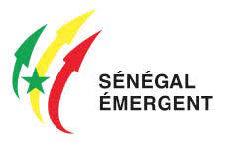
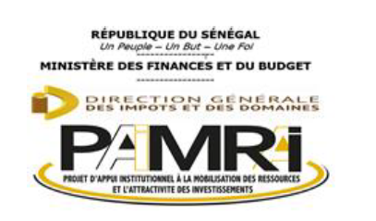

Senegal
Automotive
Industry
Development Framework

August 2023

Table of Contents
Glossary 2
A Statement by the Honourable Minister 3
Foreword by The Director of Industrial Re-deployment (DRI) 4
Snapshot of Senegal Automotive Policy Framework 5
1 Introduction 8
2 The Automotive Industry 10
2.1 Overview 10
2.2 The Global Automotive Industry 11
2.3 The African Automotive Industry 11
2.4 ECOWAS Automotive Industry 13
3 Strategic Positioning 15
3.1 Competitive Advantage 15
3.2 Strategic Position 16
4 Policy Framework 19
4.1.1 Introduction 19
4.1.2 Automotive industry considerations 19
4.1.3 Policy statement 21
4.2 Vision, Mission and Goals 21
4.2.1 Vision 21
4.2.2 Mission and Strategic Objectives 22
4.2.3 Objectives 22
4.2.4 Goals 23
4.3 STRATEGIES TO DEVELOP AUTOMOBILE INDUSTRY 24
4.4 Support to Motor Vehicle Assembly 24
4.4.1 Harmonization of standards 24
4.4.2 Collaboration Mechanisms in the Industry 25
4.5 Key focus areas of the proposed Automotive Industry Policy Framework 28
5 Implementation Plan 34
6 Skills Development 39
7 Annexure A: Policy Benchmark 42

Glossary

Sustainable Development Goals (SDGs)
Emerging Senegal Plan (PSE)
Common Industrial Policy of West Africa (PICAO).
Priority Action Plan of the first phase of the PSE (PAP1)
Senegal Automotive Industry Development Framework (SAIDF)
Economic Community of West African States (ECOWAS)
Africa Continental Free Trade Area (AfCFTA)
European Union (EU)
Electric Vehicles (EV)

A Statement by the Honourable Minister

Foreword by The Director of Industrial Re-deployment (DRI)

Snapshot of Senegal Automotive Policy Framework

1
Introduction

Introduction

In 2014 Senegal adopted the Emerging Senegal Plan (PSE) as a reference document for the country’s economic and social development strategies and policies. The PSE is an inclusive, sustainable growth strategy embodied in a portfolio of flagship projects and reforms. The strategy is aligned with the Sustainable Development Goals (SDGs), the African Union’s Agenda 2063 and the Common Industrial Policy of West Africa (PICAO). The Priority Action Plan of the first phase of the PSE (PAP1) places industry among the engines of structural transformation, economic growth and the creation of significant sustainable jobs.

As part of this ambition, the automotive industry has been identified as a sector with strong growth and job creation potential which is showing sustained economic growth and where a middle class is emerging with an improved standard of living. In the PSE the objective of the Automotive Industry Development Framework is to position Senegal in the growing automotive market in Africa, improve its economic growth and allow job creation in high demand sectors and technology. Within this Senegal aims to become a multi-brand platform for production of various types of vehicles, components, equipment and training in the automotive industry.

The realisation of the Senegal Automotive Industry Development Framework (SAIDF) should make it possible for Senegal to:
- Develop local units for assembly of new vehicles;
- Set-up local manufacturing units (sub-assembly and/or local production) of certain key components of the automotive industry value chain, tapping into local and regional mineral and energy resources;
- Set up centralised production and manufacturing clusters of automotive equipment;
- Put in place a specific legal, regulatory and fiscal framework to attract manufacturers and assemblers for the assembly of local production of vehicles;
- Set up training centres for target trades, likely to produce a highly skilled workforce for the automotive sector;
- Eventually set up complete car manufacturing plants.

It can be said that the SAIDF aims to fulfil Senegal’s stated PSE ambition of being a multi-brand platform for production of vehicles, components, equipment and training in the automotive industry. Furthermore it strengthens the case for the country to form an integral part of the regional automotive development in ECOWAS; it highlights the potential role the automotive sector can play in export led growth through trade with AfCFTA and EU Countries; it illustrates how Senegal can leapfrog in its industrialisation effort by playing in new and innovative sectors including embracing green technologies thus enabling Electric Vehicles (EV) production; levelling the playing fields by growing the industrial base which enables the inclusion of the informal sector and upskilling; and socio economic development including skills training, jobs and wealth creation.

2
The Automotive Industry

The Automotive Industry

Overview
Mobility is at the core of modern civilisation, and the way people and goods move impacts many aspects of life. The automotive industry, therefore, is one of the most significant contributors to the overall economy of the world. Policymakers in developing countries, with their goals and sights firmly set on supreme economic growth, are increasingly becoming aware of the economic benefits generated by vehicle manufacturing and widespread car ownership. Africa is home to the largest number of developing countries and the OEMS are starting to realise the potential of Africa as a substantial growth opportunity for exports as well as potential vehicle production. Africa, with its huge population base and low levels of vehicle ownership, is becoming a focal point for OEMs in terms of increased investment in the regional automotive manufacturing base.
Increasingly, volume car manufacturing is a cost-driven business and manufacturing investment projects continue to be allocated to the emerging countries. Every significant industry player is exploring new geographies, new segments, and new technologies in an effort to capture growth and create differentiation. Global integration is occurring very rapidly and is driven by lower trade barriers, including the formation and extension of regional trading blocs, as well as by the global strategies of major international firms. The trends of OEMs to shift to and locate production facilities in low-cost countries in the Far East as well as in Africa are exhibited in improvements to their international competitiveness due to low-cost manufacturing, economies of scale, better proximity to large export markets, regional trade agreements, improved political risk, security, and broadening the component manufacturing and parts supply base, while attracting new technology in domestic industries. However, the product design and marketing functions remain by and large with the parent companies’ head offices while the main production processes are copied in the developing countries.
The global automotive industry is regarded as the world’s largest manufacturing industry. The broader automotive industry spans the primary, secondary, and tertiary sectors of the economy, from agriculture and mining to the manufacturing and service industries. The automotive industry is a prime example of globalisation. Major vehicle manufacturers span the world with their instantly recognisable brands, producing vehicles at an array of plants across various continents. The industry’s products are responsible for almost half of the world’s oil consumption and its manufacturers use up nearly half of the world’s annual output of rubber, 25% of its glass and 15% of its steel.
Connectivity, autonomy, shared mobility and electric (CASE) technology represents the major trends in the industry at present, although its uptake is varied in pace and impact across different markets. These global trends have a significant impact on the development and future of the global automotive supply chain role-players, as well as the developed and developing automotive producing countries and regions.
A recent development is that the European Union plans to legislate banning the sale of internal combustion engine (ICE) vehicles in 2035. It is part of an ambitious effort to spur the use of electric vehicles with some countries and global brands already transforming to EVs by as early as 2025. The European Commission has proposed a 55% cut in CO₂ emissions from cars by 2030 compared to 2021 levels, which is much higher than the existing target of 37,5%. It has also mandated a 100% cut in CO₂ emissions by 2035, which would make it impossible to sell new ICE vehicles in 27 European countries.
Considering that second-hand and grey vehicle imports constitute more than 80% of vehicle sales in Africa, the continent could increasingly become a dumping ground for used ICE vehicles in future, negatively impacting on potential automotive industrialisation efforts if the trend is not managed and controlled by countries and regions on the continent.

The Global Automotive Industry
Contributing about three percent (3%) of global GDP , the industry is integral to generating jobs, accelerating technological advancement, building local skills, and expanding local value chains. In 2021, the global automotive industry generated an estimated US$3.1trn in the sales of 80.1mn vehicles, providing an estimated 12 million direct jobs globally . Early projections estimate that the global market is expected to reach 122.83 million by 2030 and grow at a CAGR of about 3.7% between 2020-2030.
As of 2021, Global Motorisation rates were recorded at 180/1000 with an estimated 1.5 billion vehicles. The North American and European regions were in the clear lead with above average
motorisation rates of 790/1000 and 580/1000 cars to people ratio respectively, the highest motorisation rates globally. Other leading automotive clusters like Japan and China also had significant motorisation rates. China with 170/1000 car parc, while slightly below the global average has a population of 1.4 billion. Conversely, Japan with a population of just about 125 million has car parc rates 0f 590/1000. Regardless of any differences in population and demography, one thing these regions have in common is that they are major automotive producers, supplying most of the vehicles consumed globally. In comparison, Africa, the third-largest continent by population has a car parc rate of just 40/1000 with a total of about 50 million vehicles across the continent while contributing less than 1% to global vehicle production.
The automotive industry has made a significant impact in countries where it has been established, for example Thailand. Although Thailand is a relatively new automotive manufacturing country, the automotive industry already employs over 555,000 people through 2,400 companies.

The African Automotive Industry
The automotive industry in Africa distinguishes between countries in Northern Africa, and the countries to the south that make up the sub-Saharan African (SSA) countries. Most of the countries in SSA have a low level of industrialisation with limited manufacturing capabilities. Growth prospects on the African continent remain diversified by region, with the East Africa region the fastest growing on the continent. Vehicle consumption demand on the African continent is by large being met by imports of completely built-up (CBU) units or vehicles. The markets of most countries on the African continent are retail dominated, where new vehicles sales compete with used vehicle imports, except for countries with sizeable automotive manufacturing capacities, such as South Africa, Egypt, Morocco, and Algeria, where used vehicle imports are not allowed. Low new vehicle sales as well as low local vehicle production on the African continent could be attributed to factors such as the small market size, low purchasing power, lack of industry competitiveness and inadequate government policy environments.
Most emerging market countries, as is also the case in Africa, have ongoing endeavours to grow their automotive industries as a symbol of an industrialised economy. Several larger SSA countries, such as Ghana, Kenya, and Nigeria, have implemented governmental policies to uplift domestic automotive production. The largest vehicle production plant in Africa can be found in Tangiers, Morocco, where Renault produced 210,000 vehicles in 2020. It has workforce of 6,500 employees and manufactures a range of four Renault vehicles.
Vehicle production in Africa declined by a massive 35,3%, from 1,11 million units in 2019 to 720 156 units in 2020. The continent’s market share comprised 0,93% of global vehicle production in 2020. South Africa, with 447 218 units, accounted for a substantial 62,1% of Africa’s total vehicle production in 2020, while Morocco with 248 430 units, and Egypt with 23 754 units accounted for the balance. Regarding passenger car production, South Africa, with 238 216 units, surpassed Morocco at 221 299 units in 2020 after trailing Morocco in 2018 and 2019.
New vehicle sales in Africa declined by 22,6% from 1,18 million units in 2019 to 912 863 units in 2020. In South Africa, new vehicle sales declined year-on-year by 29,2% in 2020, and in Morocco, sales declined by 19,7%, while sales in Egypt reflected an increase of 28,8% due to the deflation of the local currency in 2020. South Africa remained the dominant market on the African continent and accounted 41,7% of total African new vehicle sales.
The table below reveals the new vehicle sales figures for sub-Saharan African countries as obtained from the AAAM based on the status quo scenario with used vehicles continued to be imported into these markets.

Country | 2019 AAAM | 2025* AAAM
Mauritius | 10 200 | 13 588
Nigeria | 9 763 | 11 413
Ghana | 8 129 | 11 894
Senegal | 6 994 | 10 132
Kenya | 6 508 | 8 688
Ivory Coast | 5 398 | 7 930
Angola | 4 448 | 5 409
Mozambique | 3 760 | 5 403
Zambia | 3 279 | 3 843
Zimbabwe | 3 114 | 3 604
Ethiopia | 2 838 | 4 106
Tanzania | 2 427 | 3 333
Gabon | 2 311 | 2 690
Uganda | 2 116 | 2 906
Malawi | 1 672 | 2 183
CAR | 1 629 | 2 184
DRC | 1 550 | 2 043
Seychelles | 1 376 | 1 770
Burkina Faso | 1 235 | 1 731
Mali | 879 | 974
The demand for vehicles on the African continent is still highly income elastic. With increases in per capita income the middle class’s economic power grows exponentially more that the growth in the total economy. Key growth drivers for new car sales include the economic growth rate, a local manufacturing presence, level of import duties, a rising middle class, A presence of high-net-worth individuals and Government’s willingness to spend on infrastructure
The AfCFTA is a game-changing economic initiative which will enable greater industrialisation by creating regional production hubs to serve the entirety of Africa. From an automotive perspective, ultimately regional markets will trade vehicles and components. In this context, OEMs will play a critical role in developing regional value chains and to increase technological content of a domestic automotive industry, by fostering localisation of production of suppliers. With an integrated market under the AfCFTA, abundant labour force, a wealth of natural resources, and a growing middle class, African countries are increasingly turning their attention to support the emergence of their automotive industries. However, unlocking the great potential on the continent requires an accommodative regulatory and policy environment. The essence of a successful automotive development policy is to induce the OEM into a dynamic investment path that moves, over time and with achievable volumes of demand, from semi-knocked down (SKD - light manufacturing) to completely knocked-down (CKD - significant industrialisation) to integrated production plants (advanced manufacturing).

ECOWAS Automotive Industry

The automotive industry in the ECOWAS region is dominated by Nigeria, followed by Ivory Coast, Ghana and Senegal. The total vehicle population in ECOWAS was estimated at just over 9.5 million vehicles in 2020 with the 4 top countries accounting for almost 78% of the vehicle population in the region.

Vehicle ownership rates for ECOWAS are well below the Africa average of 44 vehicles/1 000 inhabitants, with the exception of Ivory Coast and Senegal.

Country | Population | Vehicle ownership (/1000)
Country | 2020 | Vehicle ownership (/1000)
Cape Verde | 556 000 | 105
Ghana | 31 919 641 | 34
Ivory Coast | 25 720 000 | 42
Nigeria | 201 000 000 | 23
Mauritania | 4 813 853 | 10
Senegal | 17 334 294 | 47
Benin | 12 577 004 | 25
Togo | 8 538 439 | 31
Mali | 21 044 405 | 12
Burkina Faso | 20 900 000 | 23
Gambia | 2 417 000 | 41
Guinea-Bissau | 1 900 000 | 33
Guinea | 12 400 000 | 5
Liberia | 19 100 000 | 4
Niger | 25 384 000 | 11
Sierra Leone | 7 764 750 | 11
TOTAL ECOWAS | 413 367 366 | 23

3
Strategic Positioning

Strategic Positioning

Senegal has adopted the Plan Senegal Emergent (PES) to:
  - improve infrastructure,
  - achieve economic reforms,
  - increase investment in strategic sectors,
  - and strengthen the competitiveness of the private sector.

With good air transportation links, a modern and functional international airport, planned port expansion projects, and improving ground transportation, Senegal also aims to become a regional center for logistics, services and industry.
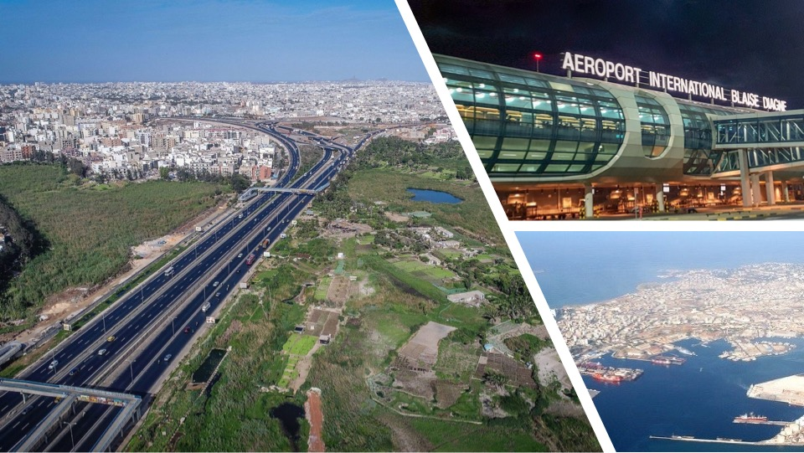
The Automotive Industry has been identified as a sector which can have a catalytic effect on the industrialization of a country.

Competitive Advantage
The value proposition of Senegal includes:
  - Its geographic location at the western end of the African continent and access to the Atlantic Ocean makes it ideal as a trade and economic hub linking Africa (ECOWAS) to Europe and the rest of the western world.
  - A stable and secure political environment and good governance.
  - Senegal has a large pool of young, educated labour that can be trained and skilled-up for an automotive industry.
  - Developing world class infrastructure such as roads/railways, renewable energy investments, ICT and Special Economic Zones.
  - Senegal’s investment code provides for incentives to boost investment in key sectors such as manufacturing.
  - As an important member of the regional economic blocs, and thanks to its strategic position, Senegal is a gateway to a large market of more than 300 million consumers in Africa.
  - The epithet of "Teranga" country - the "World Economic Forum" has ranked Senegal 6th most welcoming country in the world, according to tourists.
  - The business environment in Senegal is favorable and constantly improving. Since 2013, the Senegalese government has been implementing the Programme for the Reform of the Business Environment and Competitiveness (PREAC). This has created an enabling environment for investors.

Strategic Position
Based on the value proposition of Senegal within the automotive industry, it is proposed that the Senegal automotive strategy is aimed at positioning the country in the following key areas:
  - Vehicle marque for Senegal automotive assembly to include passenger vehicles, buses and mini buses.
  - Build on the current SKD assembly facilities in the country such as Seniran and Senbus and provide further support to these industries. Senegal can support expansion and investment in these companies, focused on conventional buses and mini-buses as well as a limited range of passenger vehicles.
  - These assembly facilities can be further developed to increase the local content of the vehicles and provide market opportunity for locally manufactured components.
  - Support local component manufacturing of selected automotive components such as automotive batteries.
  - The access to a current battery manufacturing facility in Senegal can be used as a platform to support expansion of upstream component manufacture, eg plastic injection moulding for casings and lead processing for cells.
  - Senegal is also well positioned to manufactured batteries for electric vehicles. Senegal’s proximity to other member states in the ECOWAS region, can be exploited to import raw materials for the local manufacture of automotive components and accessories.
  - The development of refineries can lead to availability of plastic raw materials. Senegal can therefore also position itself as a key supplier of molded automotive components such as interior plastic components, hang-on exterior parts such as bumpers.
  - The manufacture of selected automotive replacement parts, such as the batteries referred to above and other part such as windscreen wipers, can be encouraged.
  - Senegal can participate in the move in the automotive industry towards transition of ICE vehicles to electric vehicles.
  - Senegal can position its automotive industry to be a player in electric mobility solutions by supporting transition of the current buses, minibuses and passenger vehicles to EV drive trains and other electric vehicles such as three-wheelers (last mile delivery and commuter transport) and electric motorbikes.
  - The development of the light electric vehicle industry in Senegal requires the support of electric charging infrastructure.
  - Besides establishing the EV grid connectivity in urban areas, solar panels and battery backup can be used to provide micro-grid solutions in rural areas.
  - These micro grids can support the deployment of electric motorbikes and electric three-wheelers in rural areas, thereby creating a sustainable solution in areas that are not readily serviced with access to grid electricity and other infrastructure.

The proposed positioning needs to be supported by suitable policies (to protect the industry) and incentives (to encourage investment) from the Senegalese government to provide the enabling environment for the industry.

Financial institutions are required to develop suitable investment and financing instruments to provide the industry with suitable financial support.

4
Policy Framework

Policy Framework

Introduction
There is a need to have an Automotive Plan for 12-15 years that provides a clear vision and mission for the establishment of an automotive industry in Senegal. This should define the trajectory of evolution of the Senegal automotive ecosystem including the roadmap for specific regulations and policies that govern design, technology, testing, manufacturing, import/ export, sale, use, repair and recycling of automotive vehicles, components and services. Key areas that the policy should focus on are:
- Targets that the policy hopes to achieve: Production, exports, employment generation, contribution to the economy, etc.
- Approach towards FDI: FDI norms for OEMs as well as component manufacturers and Tier-I suppliers over the period of 10 years.
- Import duties: Approach towards determining import duties that will facilitate both domestic manufacturing as well as exports.
- Auto fuel and emission norms: A framework should be prepared which will enable introduction of emission standards like markets of interest to Senegal from both a domestic manufacturing as well as from an export perspective.
- Safety regulations and standards: A clear roadmap on developing safety standards and institutional mechanisms to support the development and implementation of standards.
- Inspection and certification regime: Approach for ensuring roadworthiness of vehicles which are in line with the standards of testing.
- End of Life (EOL) policy: Clear guidelines for automotive components and vehicles that are in line with preservation and safety of the environment. A well-defined plan to retire older vehicles should -be created.
- FTA regime: FTA regime to facilitate market access in ECOWAS and further afield in the rest of Africa and possibly also Europe and USA.
- Tax breaks and fiscal incentives: Incentives to encourage local manufacturers.
- Skill Development: Plan to ensure skill development in line with the requirements of the auto­ industry.

Automotive industry considerations
The establishment of a viable automotive manufacturing industry and the attraction of OEM and component suppliers necessitates that the final completely built-up unit (CBU) has operational integrity for efficiency and safety. This requires exacting standards and high calibre quality control systems – the OEM has a liability for the performance of its product and needs to protect its brand reputation. This need for rigorous standards applies equally to the component supply chain. Therefore the regional value chain needs to effectively be part of a wider production system and it needs to be regulated by globally recognised standards and homologation systems.
However, it is possible to develop production in stages over time precisely because the OEMs have global production systems. Different degrees of assembly are referred to as Semi-Knocked Down (SKD) and Completely Knocked Down (CKD). These are also often loosely referred to as kits. Generally there are four possible stages in this manufacturing developmental path that would confront a late starter in Africa:
- SKD 1: this is a vehicle that has been assembled fully in a CKD supplier plant and a final inspection done. There is then limited disassembly of certain larger sub-systems, which are then packaged for shipment to another plant and then assembled at that plant. These are relatively simple reassembly processes, so that there is confidence in the integrity of the reassembled vehicle. However, technical and licensing agreements are commonplace.
- SKD 2: here there may not be final assembly and sub systems and a wider range of components may be left for final assembly in the SKD plant. This requires more advanced manufacturing capacity at the recipient plant and the OEM will need to be confident that the final CBU will comply with its standards (liability and reputational issues arise). At this stage some possibilities for specific local component supply might arise, depending on the assembly methods of specific OEM.
- Basic CKD: this is a form of advanced manufacture. The CBU is assembled from componentry. The source of such componentry will be from international and local sources. Major new processes such as the paint shop and body shop operations must be invested in. The extent to which locally manufactured components are part of the assembly will depend on several factors examined below. Such a plant can only be established if the key required infrastructure is in place. This latter factor is crucial, in most start-up programmes, there is a deliberate encouragement of clustering, to make optimum use of available infrastructure and to develop pooled support services in enterprise development and training.
- Advanced CKD (Integrated Manufacturing Facility, IMF): as indicated above this is a CKD plant with significant local component input. Where the drive train is sourced from makes a significant contribution to the maturity of the supply chain. However, there is a more important dimension of the integration characteristic. This is a fuller integration of the plant into the evolving OEM production system and supply chains based on model changes over time. The plant produces several models over time, on re-tooled production lines, to meet global demand. Its suppliers do not only supply the plant but supply into the global supply chain of that OEM. It is these capacities that allow for economies of scale and global competitiveness. This is a mature stage of supplier development and it is clearly such forms of manufacturing that can more effectively induce regional value chains.
A key objective then of any national automotive manufacturing development programme is to encourage the OEM to follow such a developmental path over a few decades. Where the industrial capacity is low at the outset such a process may be extensive. However, provided certain principles are followed the impact on employment, output and the balance of payments can be significant and cumulative.

Policy statement
Recognising the pivotal role of the Automobile Industry in the development of Senegal’s industry and its contribution to the socio-economic development of the country, the Government of Senegal should provide support for the enactment of this Automotive Policy for the purpose of:
- Restructuring the industry on a paradigm that conforms to international standards and practices;
- Creating an enabling and conducive environment to consolidate existing investments and to attract new investments;
- Encouraging the industry to procure new technologies and management systems to increase efficiency and productivity;
- Providing quality products to local, regional and international consumers at competitive price;
- Alleviating poverty by creating new jobs across the full spectrum of the Auto Industry and allied commercial and trading activities, and
- Promoting pollution mitigation measures to protect public health and property.

Vision, Mission and Goals
The establishment of an Automotive Policy in Senegal needs to be supported by high level strategic guidelines as encapsulated in its Vision and Mission statements. The vision of the Senegal government’s automotive policy and development framework is premised on strategic objectives is indicated herewith.

Vision
Develop an automotive production base with strong domestic supply chains for modern, competitive and viable automobile and auto-parts industry by 2035 through: ·
- New investment measures;
- Tariff rationalisation;
- Rationalisation of import Policy;
- Establishment of infrastructure for Quality, Safety, and Environmental Standards;
- Establishment of a skills development and training programme for automotive assembly and aftermarket products and services;
- Ensure consumer welfare, and
- Establishment of Senegal Automotive Institute.

To create a sustainable automotive value chain in SENEGAL by 2035.

Mission and Strategic Objectives
- SO1: Create an institutional, legal and regulatory environment conducive to the development of an automotive industry;
- SO2: Build an integrated and competitive industrial hub dedicated to automotive assembly and manufacturing, as well as clusters for the manufacture of components and spare parts, in collaboration with the national private sector and OEMs;
- SO3 : Promote the creation of new industries in the automotive value chain by developing mineral and mining resources with a view to the energy and ecological transition.
- SO4 : Establish a program to develop skilled human resources for the automotive trades, in partnership with local training institutions and equipment manufacturers;
- SO5: Ensure financing for the implementation of the national automotive strategy (infrastructure and industrial parks, National Automotive Council (NAC), financing mechanism for new vehicle acquisitions, upgrading of production facilities and training, etc.).

Objectives
The overall objective of the proposed policy should be to provide the domestic industry with opportunities to achieve competitiveness in manufacturing and engineering of automotive products.
The specific objectives of the Senegalese National Automotive Policy are to develop national capacities for competitive automotive products manufacturing, anchored on training, innovation, research and development and to create a Senegalese Automotive Institute. These objectives include:

Enhance value addition
The policy aims to promote local manufacture of automotive products that meet the standards and specifications of Original Equipment Manufacturers (OEMs). This will provide opportunities for Joint ventures with global value chain players to produce affordable brands and models in Senegal.

Increase contribution to GDP
To support the growth of the automotive industry in Senegal for both domestic and export consumption, thereby becoming a significant contributor of the manufacturing sector GDP by 2035, with an initial impact realized by 2030.

Enhanced market access
To scale-up local production for import substitution and increase exports of automotive products to ECOWAS and the North and Sub-Saharan Africa region.

Skills development and job creation
To create a dynamic skill development eco-system and establish Senegal as a manufacturing skills centre of excellence. This focuses on quantitative and qualitative improvements in skills to ensure competitiveness and build a solid foundation for direct and indirect job creation in the automotive sector, over the next decade.

Enhance innovation, Research and Development
To give a supportive environment for innovation, R&D in the automotive sector (comprising the OEM assembly, automotive components and aftermarket parts manufacture) for local design and engineering; including developing and acquisition of disruptive technologies. This will also promote clean, safe, efficient and comfortable mobility products in the country and within the region, with a focus on environmental protection and affordability.

Goals
It will be the task of the implementation agent for the Senegal Automotive Policy to develop a set of goals and targets for the implementation of the automotive policy. However, based on the market assessment, it is proposed that the following goals could be achieved:
  - Goal 1 2028
    - Within the next five years, increase the local SKD1 assembled vehicle production in the Senegal to 20 000 units per annum.
    - Identify 2 or 3 key components that can be localised for manufacture within the region. These manufacturers can supply non-critical OEM approved components under licence agreements with the international owners of the component designs.
    - Establish automotive industrial parks.
  - Goal 2 2030
    - Establish new vehicle assembly capacity in the region and convert existing facilities to SKD2 by establishing centralised communal paint shops within the Automotive Industrial Parks to be established.
    - In order to attract OEMs for local vehicle assembly, it is proposed that the Automotive Industry Development programme include the establishment of centralised paint shops and shared logistic and training facilities.
    - The SKD2 facilities should have a minimum capacity to assemble between 5,000 and 10,000 units per annum.
    - Target output at the end of 2030 should be 30,000 units locally assembled in Senegal from at least 3 SKD2 assembly facilities.
    - Target up to 5 component manufacturers to set up sub-assembly and/or production facilities in Senegal in joint venture relationship with local companies.
  - Goal 3 2035
    - Establish new assembly facilities in Senegal and convert SKD2 facilities to Basic CKD facilities to establish a combined localised vehicle assembly capacity of 40,000 units per annum.
    - At least one basic CKD facility and 3 SKD2 facilities can be established in Senegal.
    - Increase local content of local component manufacturers to achieve 40% local content in Senegalese assembled vehicles. Identify and attract Tier1 and Tier 2 suppliers of automotive components and establish joint venture agreements with them to establish production and sub-assembly facilities in the region.

STRATEGIES TO DEVELOP AUTOMOBILE INDUSTRY

Support to Motor Vehicle Assembly
The Government should prioritize the production of commercial vehicles (buses, trucks and minibuses). Measures will also be put in place to promote production of passenger vehicles (saloons, station wagons, Sports Utility Vehicles (SUVs)), and possibly motorcycles through:
- Providing incentives on different levels of vehicle breakdown (SKD/CKD). The level of incentivization will depend on local value-added; degree of technology transfer; improvement in level of expertise; level of foreign exchange earnings; strengthening of manufacturing value chain; developing linkages within the industry; and investment in R&D;
- Promotion of a phased incubation approach to grow and graduate the local entrepreneurs in motor vehicle component manufacturing in Senegal;
- Encouraging and facilitating sub-contracting amongst established assemblers and the local SMEs;
- Hastening progression and phased advancement from SKD to CKD.

Harmonization of standards
For harmonization of motor vehicle standards to provide a legal and regulatory framework and provision related to performance-oriented test requirements and procedures for contracting parties.
Senegal should domesticate global regulations and standards by harmonizing all Regulations and Standards affecting the motor vehicle industry so as to support the policy and hence the development of the industry. This will be achieved through:
  - Identifying the missing gaps in standards and regulations for the industry and developing such standards and regulations to fill the gaps;
  - Identifying inadequacy in capacity to implement the existing regulations and establishing mechanisms to develop such capacity;
  - Development of standards including definitions of SKD/CKD. This will assist in rationalization of models in the region to lower the cost of maintenance. It will also enhance road safety through periodic testing and certification based on harmonised regional standards.

Collaboration Mechanisms in the Industry
The Government should facilitate development of the automotive industry through structured collaborations as follows:

Intra government collaboration
For successful implementation of this Policy and the full support of the manufacturing sector, all government entities that interface with the industry (Ministries, Departments, Associations and Agencies) will continuously consult on implementation and review of this Policy.
  - Industry and academia collaboration
It is proposed that the government establishes a NAC as the institutional framework to support the implementation of the policy. The NAC should include government in collaboration with stakeholders in the sector such as research institutions, universities and other learning institutions in the following areas:
- Research, Design, Development and testing
To ensure safety, product efficiency and environmental sustainability automotive industry, programs will be put in place promote research, design, and development for locally produced automotive products.
- Capacity Building
In order to address the mismatch in the training and industry skills requirements, given that the curriculum is not in-tandem with the technology, skills development and training eco-systems will be improved to provide industry demand-driven training. Industry will collaborate with relevant technical institutions in the development of relevant curriculum. Government in collaboration with the industry players will facilitate the establishment of automotive training institute for demand driven training. In addition, capacity building will be enhanced through apprenticeship and attachments of learners to the established assemblers and manufacturers for practical training.

Assemblers Collaboration
The Government will undertake periodic facility inspections to verify and accredit automotive SKD and CKD assemblers that meet the full requirements of SKD and CKD assembly in terms of facilities, parts assembled, SKD and CKD kits, testing facilities, local content procured and other applicable parameters. This will be necessary for monitoring SKD to CKD progression, moving up the value chain towards full local manufacturing.

Vehicle Assemblers and Component Manufacturers Collaboration:
To enhance uptake of local components, the Government will facilitate constant and structured collaboration between vehicle assemblers and component/parts manufacturers to progressively grow the local content to achieve a target of 40% by 2030, in line with the international best practice. In addition, the Government will promote the development of SMEs through subcontracting and partnership exchange between SMEs and the big assemblers.

Market Access for sector products and services
In order for the industry to achieve critical volume levels for both domestic and external markets, and enjoy economies of scale, the Government will:
- Give priority to local manufactures/assemblers in public procurement of automotive products and accessories;
- Support mechanisms for distinguishing between locally assembled and fully built imported units through adoption of technologies for proof-marking, coding, including microdot technologies;
- Enhance negotiation towards harmonization of rules of origin and elimination of Non-tariff barriers within the region trading blocs, as well as bilateral and multi-lateral trade agreements to facilitate growth and development of the automotive industry;
- Implement a total ban on importation of used fully built units of commercial vehicles, and a phased-out plan on importation of used FBU passenger vehicles. This will reduce the importation of used vehicles in the Senegalese market while facilitating the local manufacturers to assemble and manufacture affordable vehicles for diverse domestic market segments. Towards this, the age limit of imported passenger vehicles will be progressively raised, to expand the market for locally assembled vehicles, and importation of newer FBUs, for vehicles with engine capacity exceeding 1500cc. This could be implemented by limiting imported used vehicles:
  - 8-year to 5 years in 2025;
  - from 5 years to 3 years in 2028 and;
  - from 3 years to zero in 2035.
This will be reviewed from time to time.

- Promote model rationalization geared towards having an entry model (1) for the local market based on acceptability and affordability and (2) for export market where the participating OEMs already have a market for the particular model. This strategy will trigger sufficient volumes and therefore application of economies of scale. This will be done through a consultative and open process to develop criteria to determine the models of motor vehicles to be used in the country. Additional tax will be charged on any models outside the rationalized list.
- Improve accessibility to new and safe motor vehicles through the following measures:
  - The government supports and works with the relevant stakeholders to develop vehicle purchase schemes to enable individuals and companies to purchase new locally assembled vehicles;
  - The Government supports a progressive leasing policy for the public sector to expand access to new vehicles made in Senegal;
  - Development of a vehicle scrapping policy that will among others, grant scrapping rebates to individuals and companies to replace aged vehicles, particularly PSVs with locally assembled new vehicles. In addition, it will establish mechanisms for collection of end-of-life vehicles to facilitate recycling, reuse and remanufacturing;
  - Encourage development of standards for after sales service for training in after sales service, maintenance and repair, including accreditation and licensing of garages and service providers. This will enhance professionalism, safety and compliance to emission standards and reduction in the costs of operations.

Innovation, research and development and Technology
The government will encourage uptake of frontier technologies in manufacturing which includes cyber, big data, artificial intelligence, 3-D printing, Nano technology, drones, physical systems, internet of things, cloud computing, robotics and cognitive computing. In addition, the government will promote investments in research and development of commercially viable technologies such as electric powered cars including the batteries and charging stations. This could be done through a) Setting up a 'Technology Acquisition Fund' to acquire technologies; b)Offering incentives to motivate innovation, R&D and technology acquisition, and c) establishing automotive related training and skills development programmes at educational and vocational training institutions

Promotion of local Component/ Parts Manufacturing
Government, assemblers, and OEMs will promote growth of local component industry through:­
- Working with the local components manufacturers to generate a list of products which can be manufactured locally for use in vehicle assembly and after sales. Supporting capacity building of component manufacturers to produce local content that meet the quality standards of the OEMs. This will include developing mechanisms which will facilitate the component manufacturers to acquire the requisite technologies, designs and testing facilities;
- Facilitating OEMs to invest in or establish their plants in Senegal.

Preferences and reservation in public sector procurements
The Government will undertake preferential purchase of locally assembled motor vehicles, automotive parts and accessories, by Ministries, Departments and Agencies under the Public Procurement Rules 2008. In addition, the government will develop a Local Content policy to further enhance the growth of the local automotive industry.

Incentive schemes for Investments and reinvestments
The government in collaboration with automotive industry players will put in place an incentive scheme to attract new investments and reinvestments in motor vehicle assembly and manufacturing of parts. The incentives shall include: -
- Fiscal incentive on local content to enable investors to utilize more local content in their assembly lines thus growing the local content component in their manufactures. In so doing the capacity for component manufacturing will be enhanced;
- Production incentives to encourage local value addition, local content development and promotion of SMMEs.

Key focus areas of the proposed Automotive Industry Policy Framework
The design of the automotive policy framework for Senegal needs to be a cross cutting package which takes into account the many pillars of governance in Trade Policy, Industrial Policy, Fiscal Policy, Monetary Policy, Infrastructure and Transportation Policy, Mineral Beneficiation Policy as well as Regulatory legislation and a well-supported Institutional mechanism.
Policy | Linkage to Automotive Industry | Possible Action
Trade Policy | Enabler for trade facilitation and promotion, production and exports in the automotive industry | The policy needs to offer support to the automotive industry through enabling the modernisation of the car parc  Negotiate free trade agreements
Industrial Policy | Links with the automotive industry through promoting industrialisation and local manufacturing  Develop investment incentives | - Local manufacturing incentives;  - Import replacement policy; and  - Locally assembled vehicles supported by government – local content requirements.
Training and Skills development Policy | The OEMs and automotive component and accessories manufacturers require local skills to support assembly of vehicles and manufacture of automotive components. | - Develop suitable training at tertiary and vocational institutions to support the automotive industry.
Fiscal Policy | Financial protection and incentives development of the local automotive industry. | - Focus on duty regimes and fiscal income through duties and levies;  - Tariff protection;  - Common tariff adopted in all countries;  - Government procurement; and  - Conserve forex for infrastructure development
Monetary Policy | Foreign Currency Improvement | Support the improvement of the flow of foreign currency into ECOWAS
Infrastructure and Transport Policies | Infrastructure Development, including transport and electricity | - Prioritise infrastructure development as a tool to promote economic development;  - Facilitate easier flow of goods through improved infrastructure; and  - Lower cost of goods movement between member countries.
Mineral Beneficiation Policies | Enables local mineral beneficiation for the growth and development of each country | Use local mineral beneficiation to generate foreign currency and improve local manufacture of components
Regulatory Legislation | Structure operations and regulations in a common regime aimed at stimulating demand | Require clear-cut, common rules and regulations that are applicable and enforced in all member states
Institutional Framework | Enabler for the enforcement of legislation in Senegal | Identify common approach and watchdog/decision making body to oversee the institutional framework in ECOWAS, as well as monitor adherence to regulatory legislation  Establish juristic ECOWAS entity
Table 12-1: Key Policies and actions required.
- Trade Policy needs to be an enabler to foster the modernisation of the car parc. The gradual phase-out of old and unreliable vehicles will have a positive economic impact on the commuting public. Trade pacts such as ECOWAS inter-country regimes can stimulate demand for domestically produced vehicles for the domestic and export market. Future Trade pacts with large markets such as EU, North and South America and Asia can have a multiplier effect which will benefit the Senegalese automotive industry.
The AfCFTA is closer to home and provides Senegal with access to the world’s largest free trade area bringing together the 55 countries of the African Union (AU) and eight (8) Regional Economic Communities (RECs). The overall mandate of the AfCFTA is to create a single continental market with a population of about 1.3 billion people and a combined GDP of approximately US$ 3.4 trillion. The AfCFTA is one of the flagship projects of Agenda 2063: The Africa We Want, the African Union’s long-term development strategy for transforming the continent into a global powerhouse. As part of its mandate, the AfCFTA is to eliminate trade barriers and boost intra-Africa trade. In particular, it is to advance trade in value-added production across all service sectors of the African Economy. The AfCFTA will contribute to establishing regional value chains in Africa, enabling investment and job creation. The practical implementation of the AfCFTA has the potential to foster industrialisation, job creation, and investment, thus enhancing the competitiveness of Africa in the medium to long term.
- Industrial Policy needs to be the enabler for domestic manufacturing of vehicles. The import replacement policy should focus on banning or restricting imported vehicles above a certain age through high import duties and environmental levies (eg CO2 tax). In order to attract the OEMs to assemble rather than import their vehicles, a well-designed industrial enabling framework is required. Locally assembled vehicles need to be the vehicle of choice in Senegal markets due to reliability, affordability and lower cost of ownership during its lifecycle. This policy needs to be aligned to the ECOWAS Common External Tariff regime.
- Fiscal Policy needs to focus on duty regimes which serve as protection for locally assembled vehicles. There are two major interventions via tariff protection of industrial manufacturing activities in the automotive sector and excise duties levied to provide some income to government. It is common knowledge that OEMs as a global industry are used to the various government protection and tax regimes. They generally favour large market potential for their vehicles and then structure their assembly operations around the most beneficial countries for large scale investments. Senegal needs to follow the ECOWAS CET framework with a common tariff adopted in a harmonised fashion for all member countries. This will allow the OEMs enough protection to decide where to commence assembly operations. Excise duty can be used too as an additional revenue for the fiscus but should be used to offer investment and production remedies aimed at increasing the OEMs comparative advantages in Senegal versus other competitor countries in Africa.
- Monetary Policy. Foreign currency flows determine mainly the strength of the currencies in the country as well as determine the inflation parameters in each country. The automotive industry needs to be enabled to import components from many source countries, finance investments required to set up assembly operations in the countries of choice within Senegal and to repatriate profits and dividends freely to the country of choice. OEMs assembly operations add huge value to any country’s GDP. Since it imports SKD / CKD components, ultimately it will reduce the foreign currency outflows and increase FDI inflows in time. The potential export opportunities generate foreign currency earned through value addition in the country. The net impact of this positive trade balance is a stronger currency which can lead to more FDI in the OEM and component manufacturing sector via the First-tier supply base.
- Infrastructure and Transportation Policies. Government investment normally focuses on prioritised budget spend and is a major drain on the fiscus. Low GDP countries are prone to low spending on infrastructure such as ports, energy, rail and roads. A good example of targeted growth is Morocco which spends a large amount on improving their various ports to accommodate the increased flow of containerised goods flows through the port. This is one of the main reasons why Morocco is now the second largest manufacturer of vehicles on the African continent (after South Africa). Morocco might soon be the county with the largest number of vehicles assembled on the continent. Senegal needs to focus mainly on improved goods movement via its infrastructure spend. It will also serve the intra and inter linkages between the regions’ countries aimed at lowering the cost of goods movement between countries.
- Mineral Beneficiation policies enable governments to encourage domestic value-added activities if they are richly endowed with minerals. Senegal has potential to exploit is mineral resources (eg oil) and if enablers are put in place it can stimulate GDP growth which in turn will enrich the population which in turn will lead to higher income earnings which can encourage vehicle ownership. The policy should also seek out minerals that can be beneficiated in Senegal to directly support the local automotive value chain.
- Regulatory legislation enables ECOWAS to provide a platform with guidelines that will allow the OEMs and First tier suppliers to structure their operations in a common regime aimed at stimulating industrial demand. Vehicle operations demand clear cut regulations and policies in each country where operations commence. The Senegal automotive industry policy needs to be a well designed and developed policy and once legislated will govern the automotive industry during the establishment phases known as moving from importers to assemblers. The initial phases for assembly will be structured around re-establishing and growing brownfield SKD facilities (eg Seniran, Senbus, TATA)) to cater for the low volume demand of new vehicles which compete with unfairly imported used and grey imports.
- The institutional framework of a Senegalese entity to be created will serve to enforce legislation in Senegal. It is also important to create a harmonised approach which level the playing fields between ECOWAS States.
- Participation in ECOWAS Automotive Policy Development. Senegalese ministers and officials need to be participate in the Heads of State of ECOWAS in developing and finding a common approach for the creation of an ECOWAS entity that will serve as the watchdog and final decision-making body to govern the ECOWAS Automotive Policy Framework. Institutions governing quality standards, road ordinances, port operations, customs control, inspection of imported vehicles and components, tariff regimes, excise duty collection, investment and production incentives all needs to be in place to manage an active industrial roll-out in Senegal aligned to ECOWAS initiatives.

5
Implementation

Implementation Plan

The Senegal Automotive Policy Framework will be implemented through the following phases.

Phase 1: Adoption of National Automotive Policy Framework and ECOWAS Regional Policy Framework (3 months)

Adopt National Automotive Policy Framework:

Assess the existing automotive industry landscape in Senegal.
Develop a comprehensive National Automotive Policy Framework that outlines the goals, strategies, and measures for automotive industry development.
Consult with stakeholders including government agencies, industry associations, and potential investors.
Adopt ECOWAS Regional Policy Framework:

Align the National Automotive Policy Framework with the ECOWAS Automotive Industry Development Program (EAIDP).
Ensure that the policies and strategies proposed are in line with the regional goals and regulations.
ECOWAS Regional Value Chain Alignment:

Integrate the National Automotive Policy Framework with the ECOWAS Regional Value Chain Development Plans.
Identify areas of collaboration and opportunities for regional growth.

Phase 2: Establish National Automotive Council and Technical Working Groups (2 months)

Establish NAC:

Formulate the NAC as the central body responsible for overseeing policy implementation.
Define the roles, responsibilities, and composition of the NAC.
Technical Working Groups and Consultants:

Appoint Technical Working Groups within NAC to address specific sub-components of the Policy Framework (e.g., manufacturing, standards, research).
Consider engaging external consultants with expertise in areas requiring specialized knowledge.
These groups and consultants will contribute to finalizing requirements and developing detailed support measures.

Phase 3: Launch Senegal Auto Industry Development Policy (1 month)

Policy Launch:

Organize a high-profile event to launch the Automotive Policy.
Invite key stakeholders such as OEMs, multinational component manufacturers, government departments, industry associations, and financial institutions.
Stakeholder Engagement:

Facilitate discussions and presentations on the policy's objectives, strategies, and benefits.
Encourage collaboration and partnerships among stakeholders.

Phase 4: Implementation and Operation (20 years)

Develop Implementation Plans:

Create detailed implementation plans that break down the strategies and measures into actionable steps.
Define timelines, allocate resources, and set clear objectives for each phase of implementation.
Vision and Mission Statement:

Craft a vision and mission statement that guides the implementation and operation of the policy.
Ensure that all actions are aligned with the overarching goals.
Responsibilities and Accountabilities:

Assign roles and responsibilities to relevant government agencies, NAC, technical working groups, and other stakeholders.
Establish accountability mechanisms to monitor progress and outcomes.
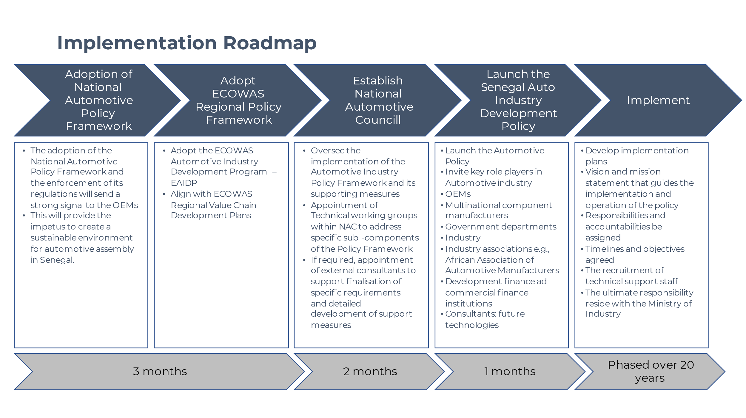
Recruitment of Technical Support Staff:

Identify the need for technical experts and professionals to support policy implementation.
Recruit skilled personnel as required to ensure successful execution.
Ministry of Industry Oversight:

Designate the Ministry of Industry as the ultimate authority responsible for policy oversight and coordination.
Ensure effective communication between the Ministry and other implementing bodies.
Remember, this is a high-level outline. Each phase will require detailed planning, resource allocation, and continuous evaluation to ensure the success of the Senegal Automotive Policy Implementation Plan over the 20-year timeline.

The NAC situated within the Ministry of Industry, assumes responsibility for the strategic formulation, development, and successful execution of the Senegal Automotive Development Policy. The NAC comprises three specialized sub-units referred to as "Auto Desks," each devoted to distinct aspects of policy implementation, fostering industry growth, and promoting sustainability.

1. Auto Desk: Policy Advocacy

Proposed Staff: Director, Deputy Director(s)

Responsibilities:

Administer and champion the Senegal Automotive Development Policy across various vehicle categories, including Passenger & Light Commercial, Medium & Heavy, Buses & Taxis, Electric Vehicles (EV), 2 & 3 Wheelers, and automotive components.
Develop and enforce Automotive Development Programme Regulations, encompassing production and localisation incentives.
Manage engagement with external experts to advise and contribute to the evolution of policy frameworks.
Engage with stakeholders across the industry to foster collaborative partnerships and gather insights for policy refinement.
Monitor, evaluate, and periodically review policy outcomes, ensuring alignment with national objectives.
Establish specialized working groups to tackle specific aspects, such as infrastructure development, skills enhancement, and other critical areas.

2. Auto Desk: Technical Working Group

Proposed Staff: Director, Deputy Director(s)

Responsibilities:

Oversee and monitor the comprehensive implementation of the Senegal Automotive Development Policy and associated programs.
Manage the registration process for automotive manufacturers, ensuring adherence to industry standards and regulatory requirements.
Foster industry engagement, promoting communication and collaboration among stakeholders.
Develop and implement a Local Content Development plan, supporting the growth of indigenous component manufacturing.
Align policy implementation with the ECOWAS Regional Value Chain development plans, ensuring regional harmonization.
Encourage the development and production of essential raw materials, including sheet metal and alloys.
Establish testing centers and homologation facilities to ensure compliance with quality and safety standards.
Provide clear guidelines for entities seeking registration as automotive manufacturers.

3. Auto Desk: Investment Facilitation (Localisation Support)

Proposed Staff: Director, Deputy Director(s)

Responsibilities:

Initiate and manage awareness campaigns highlighting Investment & Export Promotion offerings within the automotive sector.
Develop an investment pipeline by generating leads for potential investors.
Design promotional materials and organize events to showcase the opportunities available within the automotive industry.
Transform potential leads into engaged manufacturers, encouraging deeper integration into the automotive value chain.
Develop and facilitate sector-specific investment and localisation incentives to attract and retain investors.
Promote and facilitate investments in specific Hubs or Automotive Development Zones, bolstering regional industry growth.
Offer aftermarket services tailored to assist and support automotive investors in their journey.

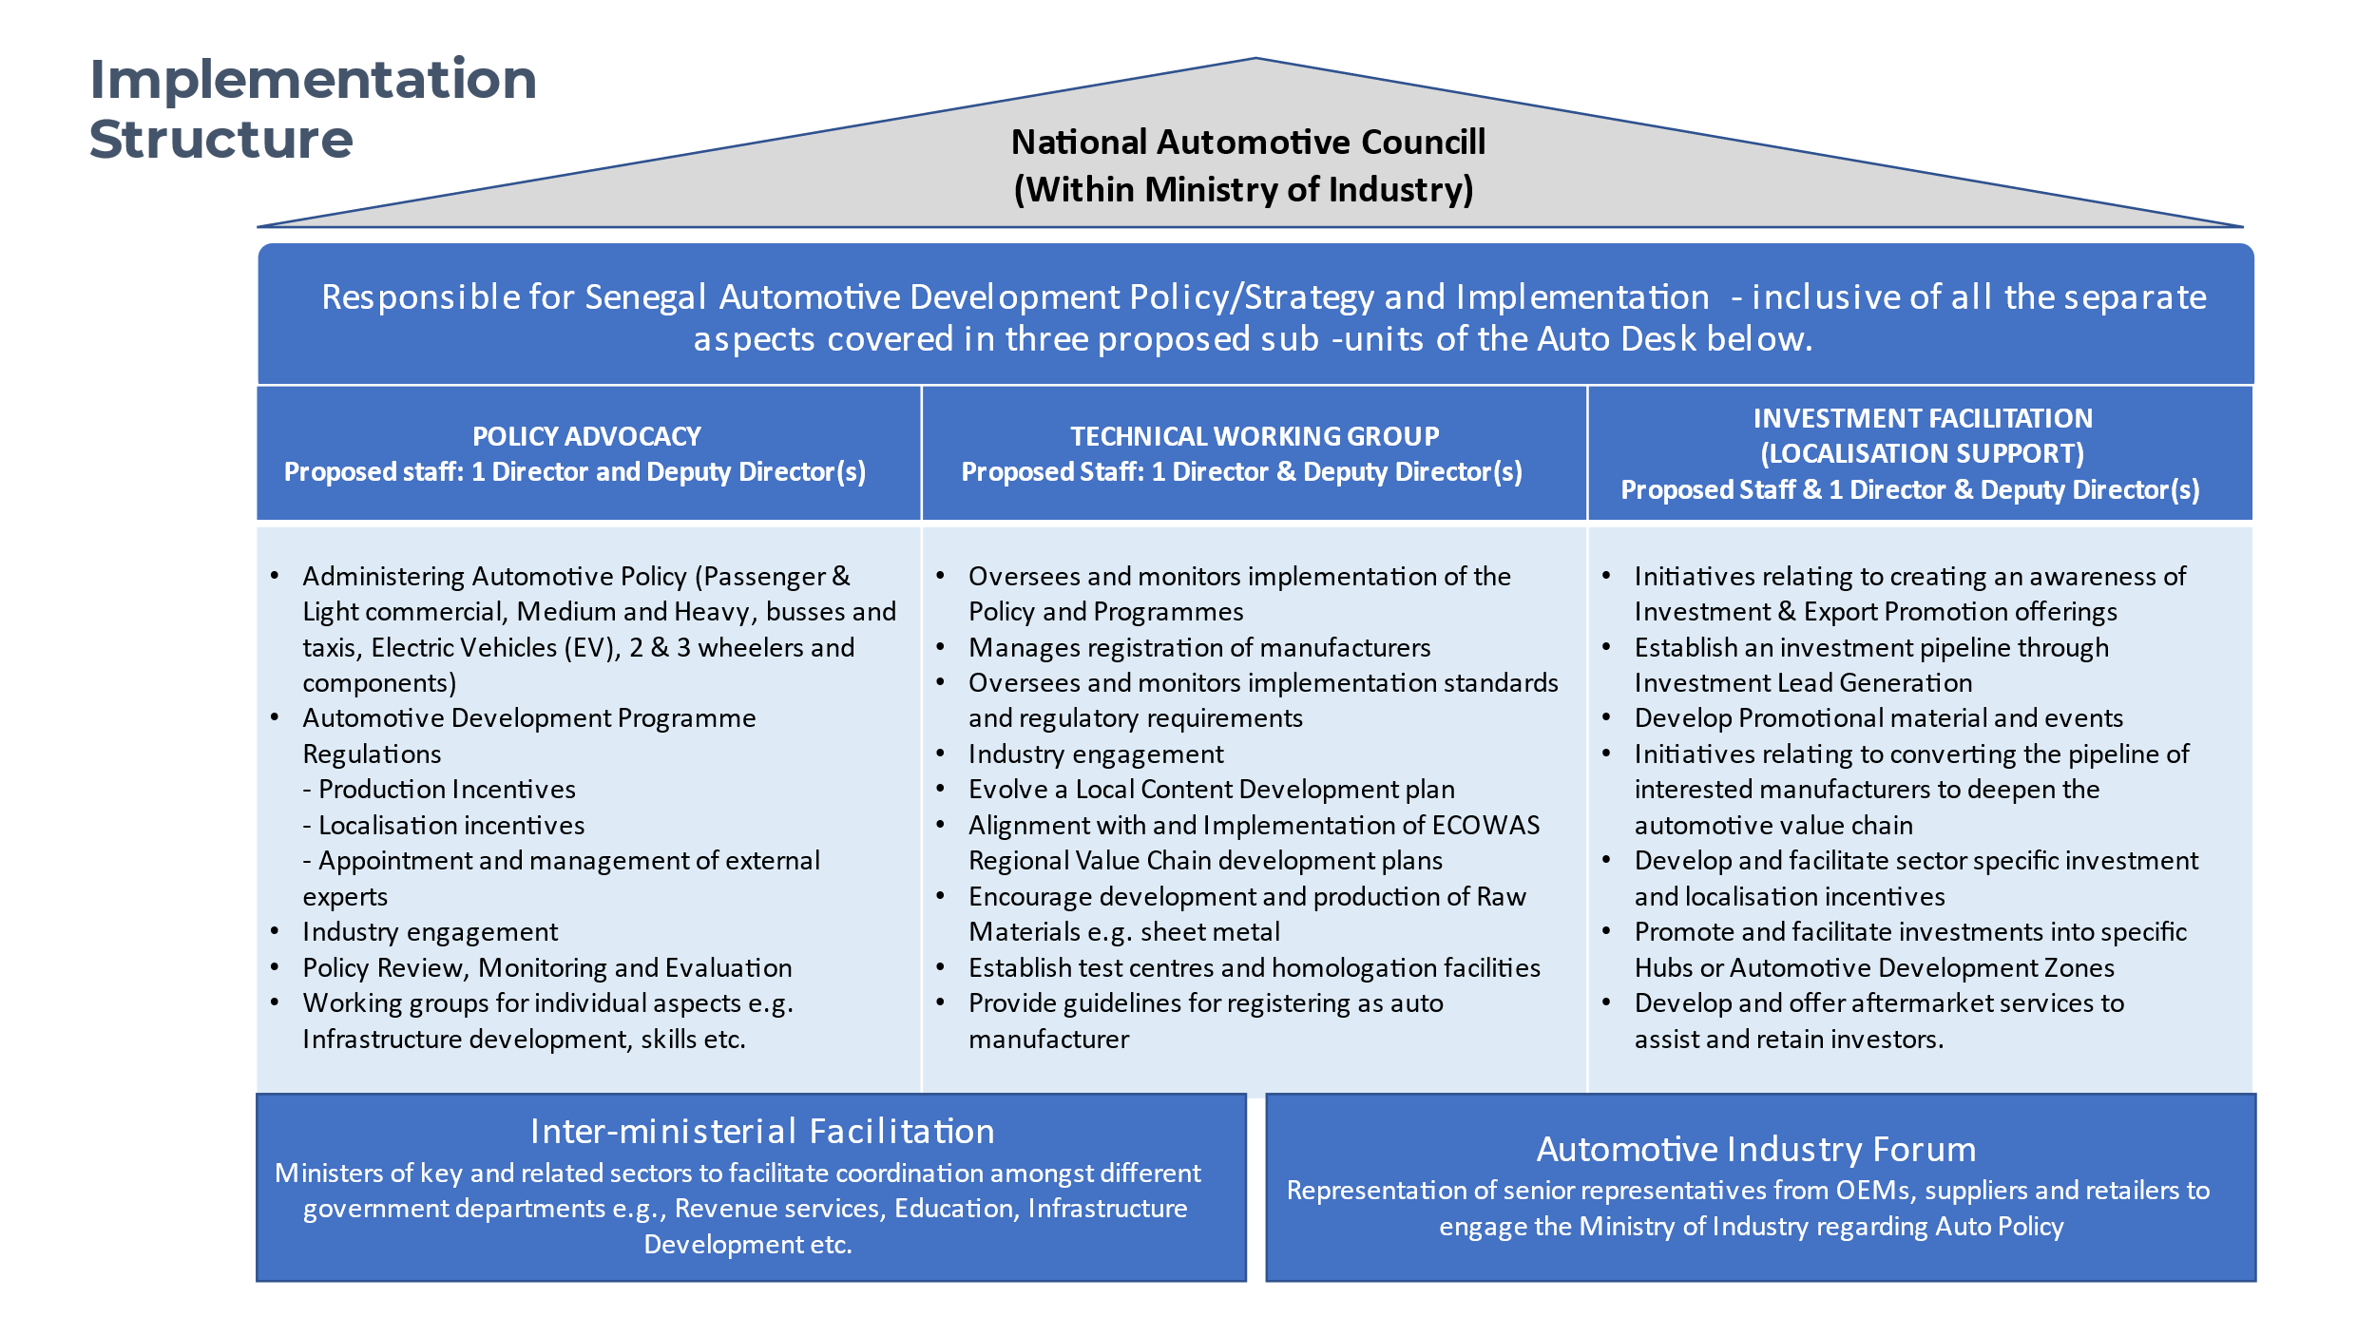
In conclusion, the establishment of the NAC within the Ministry of Industry stands as a decisive commitment towards realizing the vision and objectives of the Senegal Automotive Development Policy.
The three distinct and dynamic Auto Desks: Policy Advocacy, Technical Working Group, and Investment Facilitation, form a cohesive and strategic implementation structure. Through these Auto Desks, NAC is poised to effectively navigate the complex landscape of policy formulation, industry engagement, technical oversight, and investment facilitation. By fostering collaboration, driving innovation, and aligning with regional and global standards, the NAC's multifaceted approach demonstrates Senegal's unwavering dedication to fostering a vibrant, self-reliant, and competitive automotive sector that will undoubtedly contribute to the nation's economic growth and sustainable development.

6
Skills Development

Skills Development

Senegal will establish an Automotive Industry Development Center as implementing arm for Government’s automotive development plan. The purpose of such a center should be to, amongst others,
- Collaborate closely with all new investors and OEM’s to understand the skills required for implementing an automotive component manufacturing and vehicle assembly industry.
- Coordinate and/or provide dynamic and outcome driven skills training and technical support for the automotive manufacturing supply chain and OEMs where required

As part of the SWOT analysis, it was pointed out that:
- More than 70% of the population is below 30 years of age.
- Literacy is estimated at 52% of the entire population with a strong willingness to learn
However, certain areas required incisive action such as a lack of training of mechanics on the technological advancement of vehicles (rapid innovation of automobiles) e.g. as electronics.

Key role players in the drive to establish the automotive industry in Senegal, includes training and skills development institutions such as:
- Ministry of Labour, Social Dialogue and Relations with Institutions (MTDSRI).
- Can provide subsidies for internships within the framework of the State-Employers agreement;
- École Polytechnique de Thiès (EPT).
- Play an important role in the training of engineers and senior managers in the automotive industry supply chain.
- National Centre for Vocational Qualification (CNQP).
- As a result of cooperation between Senegal and Japan, the CFPT has specialized in training in BTI (Brevet de Technicien en Industrie) and BTS (Brevet de Technicien Supérieur) in the Electronics, Electromechanics, Auto Mechanics sectors, involving the repair of heavy machinery, the manufacture of mechanical parts, welding and plumbing.
- These facilities can be further expanded to include specific skills required for automotive assembly and component manufacturing, eg material know-how and processing technologies. This would enable the JTPF to participate actively in the training and development of qualified technicians for the automotive industry. To this end, the center is already collaborating with Cfao Motors, Dakar-Dem-Dikk (DDD), CCBM Automobile, Senbus Industries and TATA Senegal.
- Vocational and Technical Training Funding Fund (3 FPT).
- Among the 96 short-term training courses financed to the tune of 90% by the 3Fpt, about 20 already relate to the automotive industry sector.
- National Office for Vocational Training (ONFP)
- The automotive industry will require support from the ONFP to support growth in relevant outcomes and associated qualifications needed by the automotive industry.
The proposed establishment of the Automotive Industry Development Centre should introduce training and skills development programmes that draws in the educational and vocational training institutions in Senegal. External programmes can be established with specific focus areas e.g. in the component manufacturing sector:
- A program to create a skills development ecosystem that meets the needs of young people and employers in the local automotive manufacturing sector.
  - The initiative fosters collaboration between stakeholders in the automotive components manufacturing sector and technical and vocational education and training institutions.
- YA digital career guidance platform as an interactive, online career experience platform and designed to help college students and other graduates in their careers in specifically automotive component manufacturing.
  - To be designed with continuous input from OEMs, component manufacturers and the Auto Industry Development Centre, as well as college students and lecturers.

Annexure A
Automotive Policy Benchmark

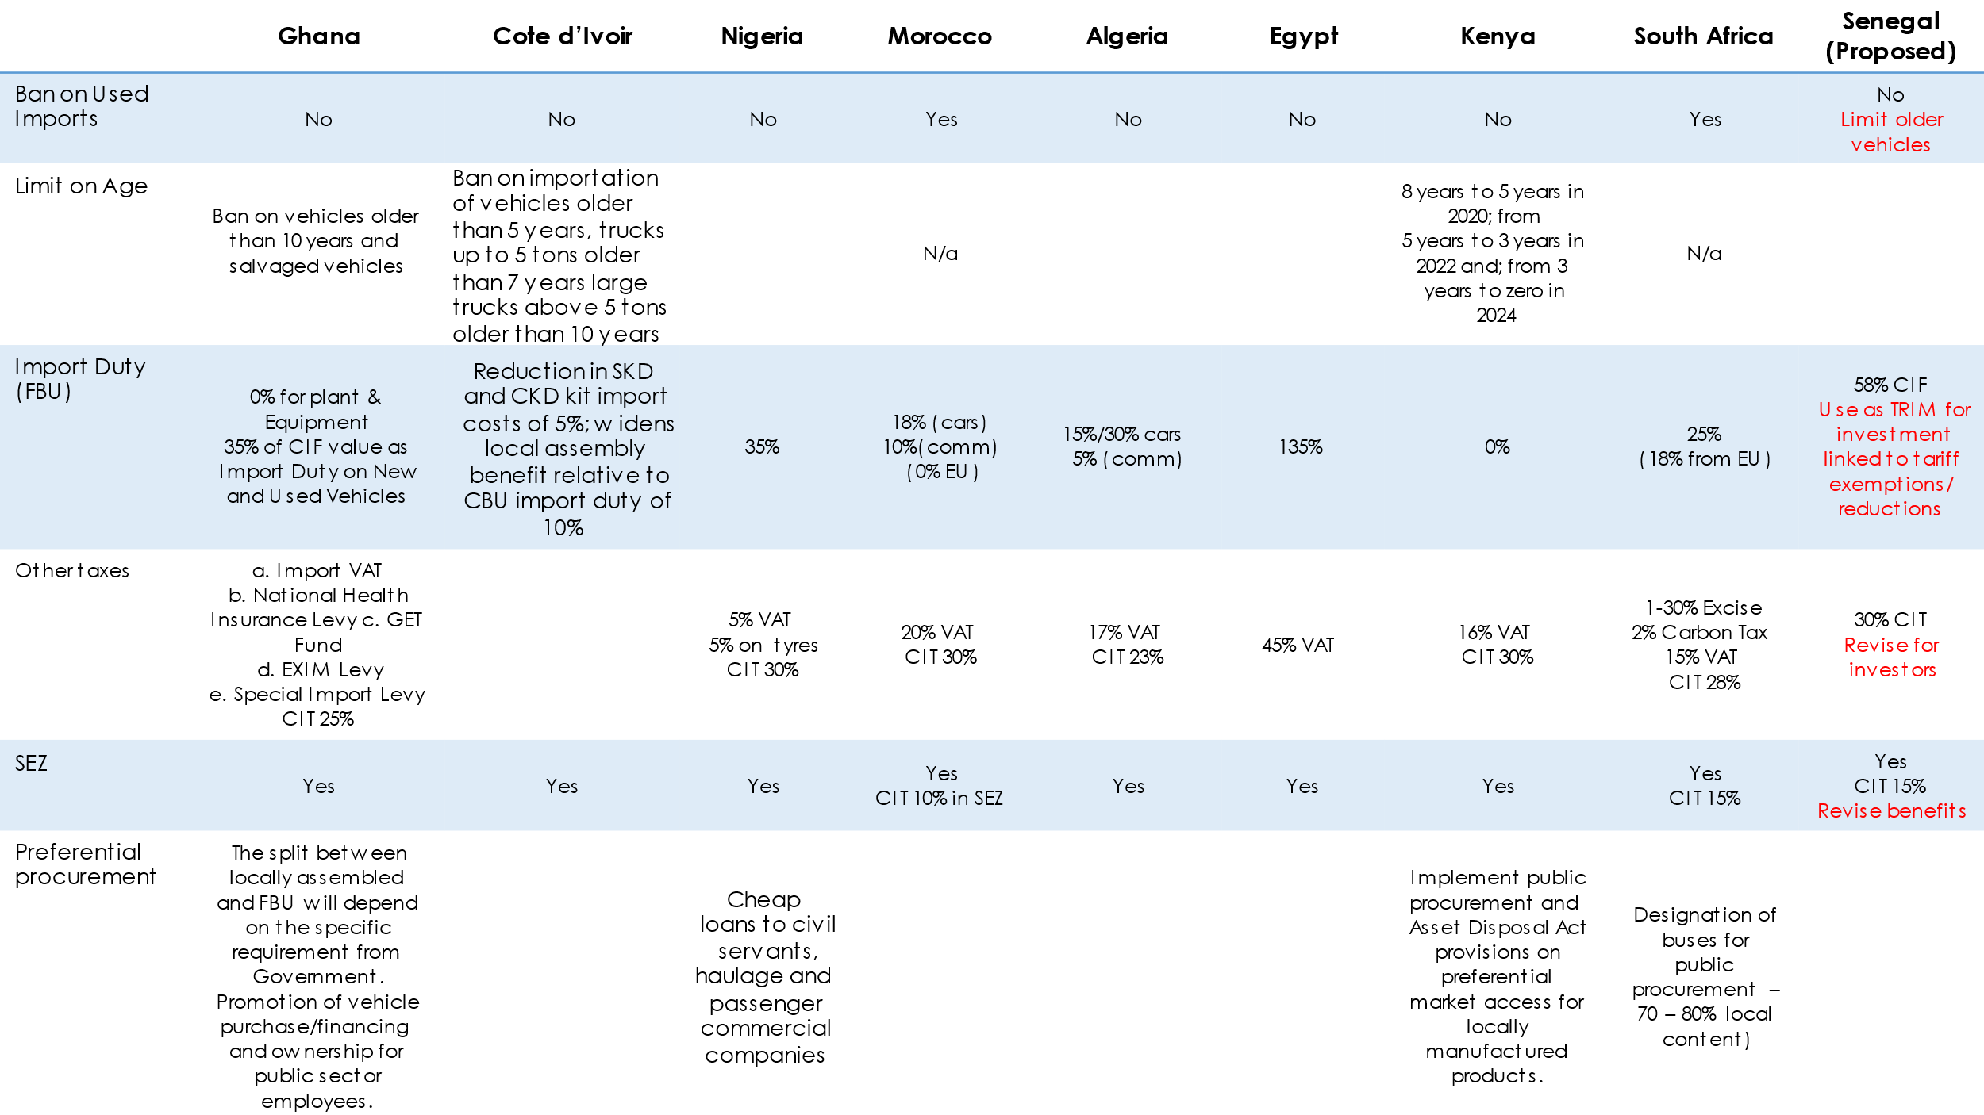
Annexure A: Policy Benchmark
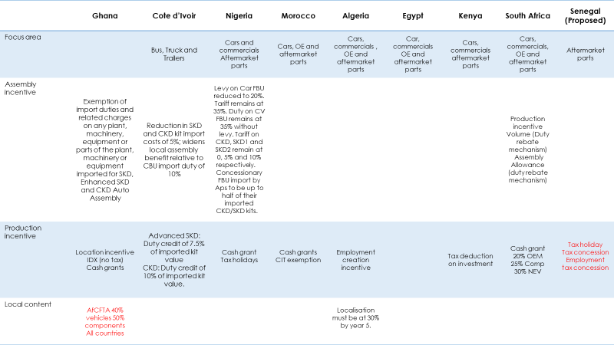

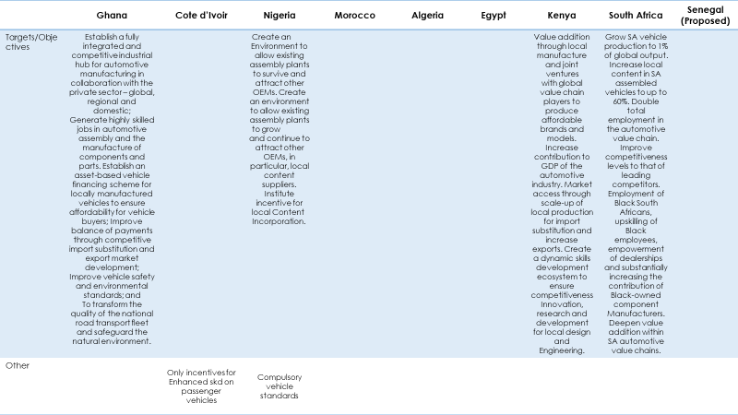

A strategy for the african automotive manufacturing sector; A concept paper. update 17 august 2021; UBU Investments

